Carbide Mould Milling Inserts
Standing standard stock
Carbide Milling Inserts
No. | Reference  Photo | Type | Grade | Material | Coating | Work-piece  Materials
1 | 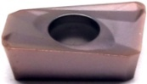 | APMT1135PDER-H2 | MS3015 | Carbide | PVD | Steel, S.S
2 | 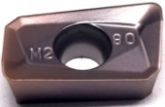 | APMT1135PEDR-M2 | MS3015 | Carbide | PVD | Steel, S.S
3 | 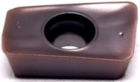 | APMT1135-TT | MS3015 | Carbide | PVD | Steel, S.S
4 | 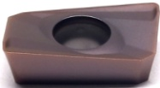 | APMT1604PDER-H2 | MS3015 | Carbide | PVD | Steel, S.S
5 | 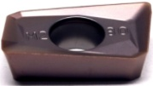 | APMT1604PDER-M2 | MS3015 | Carbide | PVD | Steel, S.S
6 | 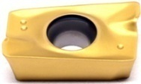 | APMT1604-TT | MS3020 | Carbide | PVD | Steel, S.S
7 | 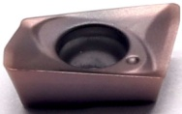 | JDMT070204R | MS3015 | Carbide | PVD | Steel, S.S
8 |  | JDMT070208R | MS3015 | Carbide | PVD | Steel, S.S
9 | 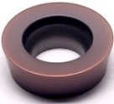 | R5-TT | MS3015 | Carbide | PVD | Steel, S.S
10 | 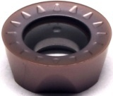 | RPMT08T2MO-SL | MS3015 | Carbide | PVD | Steel, S.S
11 |  | RPMT10T3MO-SL | MS3015 | Carbide | PVD | Steel, S.S
13 |  | RPMT1204MO-SL | MS3015 | Carbide | PVD | Steel, S.S
14 |  | RPMT1606MO-SL | MS3015 | Carbide | PVD | Steel, S.S
15 | 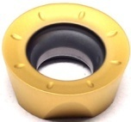 | RPMT10T3MO-TT | MS3020 | Carbide | PVD | Steel, S.S
16 |  | RPMT1204MO-TT(R6-TT) | MS3020 | Carbide | PVD | Steel, S.S
17 | 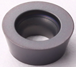 | R5-A27 | MS3015 | Carbide | PVD | Steel, S.S
18 | 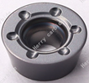 | R6-A27 | MS3015 | Carbide | PVD | Steel, S.S

Grade: MS3015
An advanced PVD (AITIN) coating material the substrate is a high hardness material, suitable for stainless steel, high hardness material finishing.

 | Recommended Cutting Parameters
 | Insert Type | Ap | F | Vc
 | APMT-H2 | 0.25-1.2 | 0.05-0.7 | 50-100
 | APMT-TT | 0.25-1.25 | 0.05-0.5 | 60-120
 | R-TT | 0.4-3.5 | 0.09-0.28 | 35-60

