Carbide Threading Inserts
Standing standard stock
Carbide Threading Inserts
No. | Reference  Photo | Type | Grade | Material | Coating | Work-piece  Materials
1 | 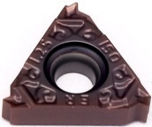 | 16ER100ISO-TLZ | MS3015 | Carbide | PVD | Steel, S.S
2 |  | 16ER125ISO-TLZ | MS3015 | Carbide | PVD | Steel, S.S
3 |  | 16ER150ISO-TLZ | MS3015 | Carbide | PVD | Steel, S.S
4 |  | 16ER175ISO-TLZ | MS3015 | Carbide | PVD | Steel, S.S
5 |  | 16ER200ISO-TLZ | MS3015 | Carbide | PVD | Steel, S.S
6 |  | 16ER250ISO-TLZ | MS3015 | Carbide | PVD | Steel, S.S
7 |  | 16ER300ISO-TLZ | MS3015 | Carbide | PVD | Steel, S.S
8 | 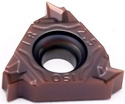 | 16IR100ISO-TLZ | MS3015 | Carbide | PVD | Steel, S.S
9 |  | 16IR125ISO-TLZ | MS3015 | Carbide | PVD | Steel, S.S
10 |  | 16IR150ISO-TLZ | MS3015 | Carbide | PVD | Steel, S.S
11 |  | 16IR175ISO-TLZ | MS3015 | Carbide | PVD | Steel, S.S
12 |  | 16IR200ISO-TLZ | MS3015 | Carbide | PVD | Steel, S.S
13 |  | 16IR250ISO-TLZ | MS3015 | Carbide | PVD | Steel, S.S
14 |  | 16IR300ISO-TLZ | MS3015 | Carbide | PVD | Steel, S.S
15 | 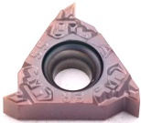 | 16ERA55-TLZ | MS3015 | Carbide | PVD | Steel, S.S
16 | 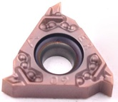 | 16ERA60-TLZ | MS3015 | Carbide | PVD | Steel, S.S
17 | 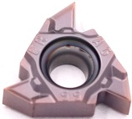 | 16ERAG55-TLZ | MS3015 | Carbide | PVD | Steel, S.S
18 |  | 16ERAG60-TLZ | MS3015 | Carbide | PVD | Steel, S.S
19 | 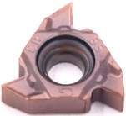 | 16ERG55-TLZ | MS3015 | Carbide | PVD | Steel, S.S
20 |  | 16ERG60-TLZ | MS3015 | Carbide | PVD | Steel, S.S
21 | 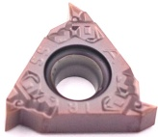 | 16IRA55-TLZ | MS3015 | Carbide | PVD | Steel, S.S
22 | 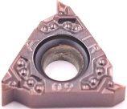 | 16IRA60-TLZ | MS3015 | Carbide | PVD | Steel, S.S
23 | 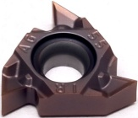 | 16IRAG55-TLZ | MS3015 | Carbide | PVD | Steel, S.S
24 |  | 16IRAG60-TLZ | MS3015 | Carbide | PVD | Steel, S.S
25 | 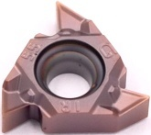 | 16IRG55-TLZ | MS3015 | Carbide | PVD | Steel, S.S
26 |  | 16IRG60-TLZ | MS3015 | Carbide | PVD | Steel, S.S
27 | 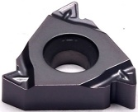 | 16ER100-69 | MS3030 | Carbide | PVD | Steel, S.S
28 |  | 16ER125-69 | MS3030 | Carbide | PVD | Steel, S.S
29 |  | 16ER150-69 | MS3030 | Carbide | PVD | Steel, S.S
30 |  | 16ER175-69 | MS3030 | Carbide | PVD | Steel, S.S
31 |  | 16ER200-69 | MS3030 | Carbide | PVD | Steel, S.S
32 |  | 16ER250-69 | MS3030 | Carbide | PVD | Steel, S.S
33 |  | 16ER300-69 | MS3030 | Carbide | PVD | Steel, S.S
34 | 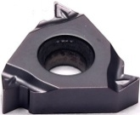 | 16NR100-69 | MS3030 | Carbide | PVD | Steel, S.S
35 |  | 16NR125-69 | MS3030 | Carbide | PVD | Steel, S.S
36 |  | 16NR150-69 | MS3030 | Carbide | PVD | Steel, S.S
37 |  | 16NR175-69 | MS3030 | Carbide | PVD | Steel, S.S
38 |  | 16NR200-69 | MS3030 | Carbide | PVD | Steel, S.S
39 |  | 16NR250-69 | MS3030 | Carbide | PVD | Steel, S.S
40 |  | 16NR300-69 | MS3030 | Carbide | PVD | Steel, S.S
41 | 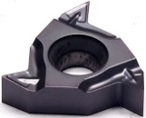 | 16ERAG55-69 | MS3030 | Carbide | PVD | Steel, S.S
42 |  | 16ERAG60-69 | MS3030 | Carbide | PVD | Steel, S.S
43 | 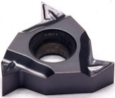 | 16NRAG55-69 | MS3030 | Carbide | PVD | Steel, S.S
44 |  | 16NRAG60-69 | MS3030 | Carbide | PVD | Steel, S.S
45 | 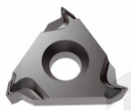 | 16ER11W-69 | MS3030 | Carbide | PVD | Steel, S.S
46 |  | 16ER14W-69 | MS3030 | Carbide | PVD | Steel, S.S
47 | 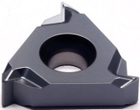 | 16NR11W-69 | MS3030 | Carbide | PVD | Steel, S.S
48 |  | 16NR14W-69 | MS3030 | Carbide | PVD | Steel, S.S
Grade: MS3015
PVD (TiAlSiN), The versatile substrate combined with the nano -composite multi-layer silicon-containing coating, high hardness, high oxidation resistance, and low friction coefficient, making the cutting smoother. It is suitable for finishing to semi-finishing of various steels and stainless steel.
Grade: MS3030
PVD (AlTiN), High Co content and fine WC grain substrate, combine with PVD AlTiN coating, which has outstanding wear resistance. Suitable for steel and stainless steel drilling.

-TLZ groove type
Grade: MS3015
A PVD material with good stability can reflect the optimal impact resistance and wear resistance when processing steel parts and stainless steel.
Recommended Cutting Parameters
Insert Type | Ap | NAP | Vc
16IR-TLZ | 0.58-1.73 | 5-12 | 100-150
16ER-TLZ | 0.61-1.84 | 5-12 | 100-150

-69 groove type
Grade : MS3030
A PVD (Al TiSiN) composite coating which is suitable for processing stainless steel,
Un-alloyed steel, hardened steel, cast iron and other materials.
Recommended Cutting Parameters
Insert Type | Ap | NAP | Vc
16IR-69 | 0.29-1.73 | 4-12 | 120-170
16ER-69 | 0.31-1.84 | 4-12 | 120-170

