- Cermet Threading Inserts
Standard stock:
Cermet Threading Inserts
No. | Reference  Photo | Type | Grade | Material | Coating | Work-piece Materials
1 | 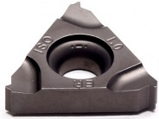 | 16ER1.0 | T45A | Cermet | Uncoated | Steel
2 |  | 16ER1.5 | T45A | Cermet | Uncoated | Steel
3 |  | 16ER2.0 | T45A | Cermet | Uncoated | Steel
4 |  | 16ER2.5 | T45A | Cermet | Uncoated | Steel
5 |  | 16ER3.0 | T45A | Cermet | Uncoated | Steel
6 | 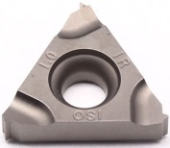 | 16IR1.0 | T45A | Cermet | Uncoated | Steel
7 |  | 16IR1.5 | T45A | Cermet | Uncoated | Steel
8 |  | 16IR2.0 | T45A | Cermet | Uncoated | Steel
9 |  | 16IR2.5 | T45A | Cermet | Uncoated | Steel
10 |  | 16IR3.0 | T45A | Cermet | Uncoated | Steel
11 | 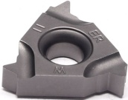 | 16ER11W | T45A | Cermet | Uncoated | Steel
12 |  | 16ER14W | T45A | Cermet | Uncoated | Steel
13 | 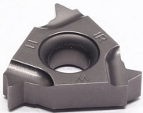 | 16IR11W | T45A | Cermet | Uncoated | Steel
14 |  | 16IR14W | T45A | Cermet | Uncoated | Steel
15 | 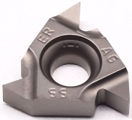 | 16ERAG55 | T45A | Cermet | Uncoated | Steel
16 |  | 16ERAG60 | T45A | Cermet | Uncoated | Steel
17 | 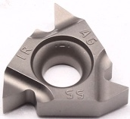 | 16IRAG55 | T45A | Cermet | Uncoated | Steel
18 |  | 16IRAG60 | T45A | Cermet | Uncoated | Steel
Grade:
T45A (TiCN) based cermet material, with strong crater wear resistance and can withstand certain impact loads, suitable for semi-finish of low-carbon steel, low-alloy steel, gray cast iron, silicon-aluminum alloy and stainless steel.

