Carbide High Feed Milling Inserts
It has a small main declination Angle and a light cutting groove, which makes it possible to achieve a high feed per tooth at a small cutting depth. At the same time, because more teeth are added, the metal removal rate can be greatly improved, and the stability and reliability can be improved. In addition, it can reduce the vibration tendency of long tools.
Carbide High Feed Milling Inserts
No. | Reference  Photo | Type | Grade | Material | Coating | Work-piece  Materials
4 | 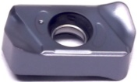 | LNMU030303 | MS3015 | Carbide | PVD | Steel, S.S
6 |  | LNMU030303 | MS3015 | Carbide | PVD | Steel, S.S
7 | 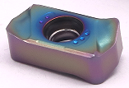 | LNMX030312 | MS1010 | Carbide | PVD | Steel, S.S
8 | 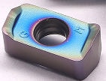 | LNEX030310ER | MS1010 | Carbide | PVD | Steel, S.S
10 | 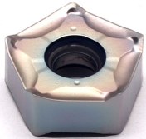 | PNMU090508 | MS3015 | Carbide | PVD | Steel, S.S
11 | 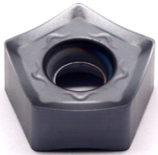 | PNGG0806 | MS3030 | Carbide | PVD | Steel, S.S  Cast iron
12 | 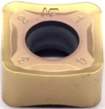 | SNMX120620-GK | TBG2305 | Carbide | CVD | Steel, S.S  Cast iron
13 | 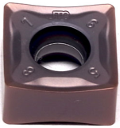 | SNMX120608-MF | MS3015 | Carbide | PVD | Steel, S.S
14 | 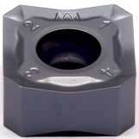 | SNMX1206ANN-MM | MS3030 | Carbide | PVD | Steel, S.S  Cast iron
15 | 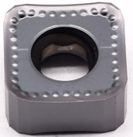 | SNGG1206AN-GT | MS3030 | Carbide | PVD | Steel, S.S  Cast iron
 |  | SNGG1507AN-GT
Grade: MS3015
An advanced PVD (AITIN) coating material the substrate is a high hardness material, suitable for stainless steel, high hardness material finishing.
Grade: MS1010
Ultra-fine-grain WC substrate combined with AlTiN coating, suitable for turning and milling of stainless steel and high hard materials.

