4. Cermet Die Milling Inserts
Standard stock:
Cermet Milling Inserts
No. | Reference  Photo | Type | Grade | Material | Coating | Work-piece  Materials
1 | 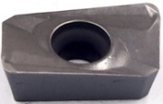 | APMT1135-H2 | T45A | Cermet | Uncoated | Steel
2 | 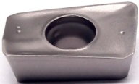 | APMT1135-TT | T45A | Cermet | Uncoated | Steel
3 | 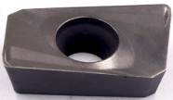 | APMT1604-H2 | T45A | Cermet | Uncoated | Steel
4 | 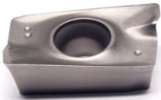 | APMT1604-TT | T45A | Cermet | Uncoated | Steel
5 | 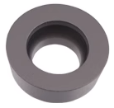 | R5-TT | T45A | Cermet | Uncoated | Steel
6 | 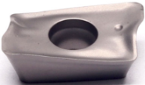 | R39011T308M-PL | T45A | Cermet | Uncoated | Steel
7 | 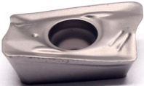 | R39011T308M-PM | T45A | Cermet | Uncoated | Steel
8 | 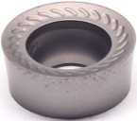 | RCKT10T3M0-ST | T45A | Cermet | Uncoated | Steel
9 | 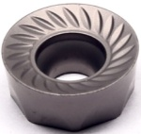 | RCKT1204M0-ST | T45A | Cermet | Uncoated | Steel

Grade:
T45A (TiCN) based cermet material, with strong crater wear resistance and can withstand certain impact loads, suitable for semi-finish of low-carbon steel, low-alloy steel, gray cast iron, silicon-aluminum alloy and stainless steel.

