Carbide Turning Inserts for S.S and Steel General Use
The types of standard stock turning inserts are Carbide SL series, Carbide KLY series.
Carbide Inserts-SL Series
No. |  | Reference  Photo |  | Type |  | Grade |  | Material |  | Coating |  | Work-piece Materials
1 |  | 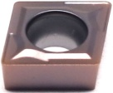 |  | CCMT060202-TF |  | MS3015 |  | Carbide |  | PVD |  | Normal Steel, S.S
2 |  |  |  | CCMT060204-TF |  | MS3015 |  | Carbide |  | PVD |  | Normal Steel, S.S
3 |  |  |  | CCMT060208-TF |  | MS3015 |  | Carbide |  | PVD |  | Normal Steel, S.S
4 |  |  |  | CCMT09T302-TF |  | MS3015 |  | Carbide |  | PVD |  | Normal Steel, S.S
5 |  |  |  | CCMT09T304-TF |  | MS3015 |  | Carbide |  | PVD |  | Normal Steel, S.S
6 |  |  |  | CCMT09T308-TF |  | MS3015 |  | Carbide |  | PVD |  | Normal Steel, S.S
7 |  |  |  | CCMT120404-TF |  | MS3015 |  | Carbide |  | PVD |  | Normal Steel, S.S
8 |  |  |  | CCMT120408-TF |  | MS3015 |  | Carbide |  | PVD |  | Normal Steel, S.S
9 |  | 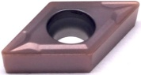 |  | DCMT070202-TF |  | MS3015 |  | Carbide |  | PVD |  | Normal Steel, S.S
10 |  |  |  | DCMT070204-TF |  | MS3015 |  | Carbide |  | PVD |  | Normal Steel, S.S
11 |  |  |  | DCMT070208-TF |  | MS3015 |  | Carbide |  | PVD |  | Normal Steel, S.S
12 |  |  |  | DCMT11T304-TF |  | MS3015 |  | Carbide |  | PVD |  | Normal Steel, S.S
13 |  |  |  | DCMT11T308-TF |  | MS3015 |  | Carbide |  | PVD |  | Normal Steel, S.S
14 |  | 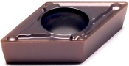 |  | DCMT070204-MV |  | MS3015 |  | Carbide |  | PVD |  | Normal Steel, S.S
15 |  |  |  | DCMT11T302-MV |  | MS3015 |  | Carbide |  | PVD |  | Normal Steel, S.S
16 |  |  |  | DCMT11T304-MV |  | MS3015 |  | Carbide |  | PVD |  | Normal Steel, S.S
17 |  |  |  | DCMT11T308-MV |  | MS3015 |  | Carbide |  | PVD |  | Normal Steel, S.S
18 |  | 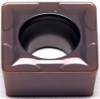 |  | SCMT09T304-TF |  | MS3015 |  | Carbide |  | PVD |  | Normal Steel, S.S
19 |  |  |  | SCMT09T308-TF |  | MS3015 |  | Carbide |  | PVD |  | Normal Steel, S.S
20 |  |  |  | SCMT120404-TF |  | MS3015 |  | Carbide |  | PVD |  | Normal Steel, S.S
21 |  |  |  | SCMT120408-TF |  | MS3015 |  | Carbide |  | PVD |  | Normal Steel, S.S
22 |  | 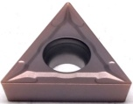 |  | TCMT090204-TF |  | MS3015 |  | Carbide |  | PVD |  | Normal Steel, S.S
23 |  |  |  | TCMT110202-TF |  | MS3015 |  | Carbide |  | PVD |  | Normal Steel, S.S
24 |  |  |  | TCMT110204-TF |  | MS3015 |  | Carbide |  | PVD |  | Normal Steel, S.S
25 |  |  |  | TCMT110208-TF |  | MS3015 |  | Carbide |  | PVD |  | Normal Steel, S.S
26 |  |  |  | TCMT16T304-TF |  | MS3015 |  | Carbide |  | PVD |  | Normal Steel, S.S
27 |  |  |  | TCMT16T308-TF |  | MS3015 |  | Carbide |  | PVD |  | Normal Steel, S.S
28 |  | 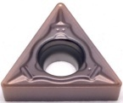 |  | TCMT110202-69 |  | MS3015 |  | Carbide |  | PVD |  | Normal Steel, S.S
29 |  |  |  | TCMT110204-69 |  | MS3015 |  | Carbide |  | PVD |  | Normal Steel, S.S
30 |  |  |  | TCMT110208-69 |  | MS3015 |  | Carbide |  | PVD |  | Normal Steel, S.S
31 |  | 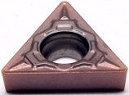 |  | TCMT110204-HX |  | MS3015 |  | Carbide |  | PVD |  | Normal Steel, S.S
32 |  |  |  | TCMT110208-HX |  | MS3015 |  | Carbide |  | PVD |  | Normal Steel, S.S
33 |  | 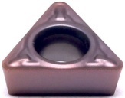 |  | TPMH090204-MV |  | MS3015 |  | Carbide |  | PVD |  | Normal Steel, S.S
34 |  |  |  | TPMH110304-MV |  | MS3015 |  | Carbide |  | PVD |  | Normal Steel, S.S
35 |  |  |  | TPMH110308-MV |  | MS3015 |  | Carbide |  | PVD |  | Normal Steel, S.S
36 |  |  |  | VBMT110304-MV |  | MS3015 |  | Carbide |  | PVD |  | Normal Steel, S.S
37 |  | 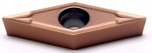 |  | VBMT160404-TF |  | MS3015 |  | Carbide |  | PVD |  | Normal Steel, S.S
38 |  |  |  | VBMT160408-TF |  | MS3015 |  | Carbide |  | PVD |  | Normal Steel, S.S
39 |  | 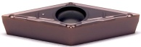 |  | VBMT160404-MV |  | MS3015 |  | Carbide |  | PVD |  | Normal Steel, S.S
40 |  |  |  | VBMT160408-MV |  | MS3015 |  | Carbide |  | PVD |  | Normal Steel, S.S
41 |  | 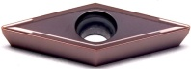 |  | VCMT110304-GV |  | MS3015 |  | Carbide |  | PVD |  | Normal Steel, S.S
42 |  |  |  | VCMT160404-GV |  | MS3015 |  | Carbide |  | PVD |  | Normal Steel, S.S
43 |  | 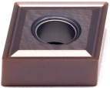 |  | CNMG090304-MS |  | MS3015 |  | Carbide |  | PVD |  | Normal Steel, S.S
44 |  |  |  | CNMG090308-MS |  | MS3015 |  | Carbide |  | PVD |  | Normal Steel, S.S
45 |  |  |  | CNMG120404-MS |  | MS3015 |  | Carbide |  | PVD |  | Normal Steel, S.S
46 |  |  |  | CNMG120408-MS |  | MS3015 |  | Carbide |  | PVD |  | Normal Steel, S.S
47 |  | 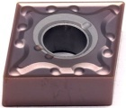 |  | CNMG120404-SL |  | MS3015 |  | Carbide |  | PVD |  | Normal Steel, S.S
48 |  |  |  | CNMG120408-SL |  | MS3015 |  | Carbide |  | PVD |  | Normal Steel, S.S
49 |  | 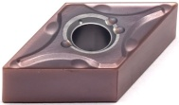 |  | DNMG150404-SL |  | MS3015 |  | Carbide |  | PVD |  | Normal Steel, S.S
50 |  |  |  | DNMG150408-SL |  | MS3015 |  | Carbide |  | PVD |  | Normal Steel, S.S
51 |  |  |  | DNMG150604-SL |  | MS3015 |  | Carbide |  | PVD |  | Normal Steel, S.S
52 |  |  |  | DNMG150608-SL |  | MS3015 |  | Carbide |  | PVD |  | Normal Steel, S.S
53 |  | 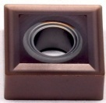 |  | SNMG120404-MS |  | MS3015 |  | Carbide |  | PVD |  | Normal Steel, S.S
54 |  |  |  | SNMG120408-MS |  | MS3015 |  | Carbide |  | PVD |  | Normal Steel, S.S
55 |  |  |  | SNMG120412-MS |  | MS3015 |  | Carbide |  | PVD |  | Normal Steel, S.S
56 |  | 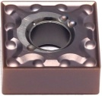 |  | SNMG120404-SL |  | MS3015 |  | Carbide |  | PVD |  | Normal Steel, S.S
57 |  |  |  | SNMG120408-SL |  | MS3015 |  | Carbide |  | PVD |  | Normal Steel, S.S
58 |  |  |  | SNMG120412-SL |  | MS3015 |  | Carbide |  | PVD |  | Normal Steel, S.S
59 |  | 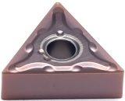 |  | TNMG160404-SL |  | MS3015 |  | Carbide |  | PVD |  | Normal Steel, S.S
60 |  |  |  | TNMG160408-SL |  | MS3015 |  | Carbide |  | PVD |  | Normal Steel, S.S
61 |  |  |  | TNMG160412-SL |  | MS3015 |  | Carbide |  | PVD |  | Normal Steel, S.S
62 |  | 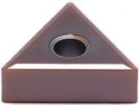 |  | TNMG160404-MS |  | MS3015 |  | Carbide |  | PVD |  | Normal Steel, S.S
63 |  |  |  | TNMG160408-MS |  | MS3015 |  | Carbide |  | PVD |  | Normal Steel, S.S
64 |  | 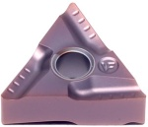 |  | TNMG160404L-VF |  | MS3015 |  | Carbide |  | PVD |  | Normal Steel, S.S
65 |  |  |  | TNMG160408L-VF |  | MS3015 |  | Carbide |  | PVD |  | Normal Steel, S.S
66 |  |  |  | TNMG160404R-VF |  | MS3015 |  | Carbide |  | PVD |  | Normal Steel, S.S
67 |  |  |  | TNMG160408R-VF |  | MS3015 |  | Carbide |  | PVD |  | Normal Steel, S.S
68 |  | 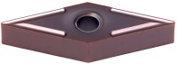 |  | VNMG160404-GV |  | MS3015 |  | Carbide |  | PVD |  | Normal Steel, S.S
69 |  |  |  | VNMG160408-GV |  | MS3015 |  | Carbide |  | PVD |  | Normal Steel, S.S
70 |  | 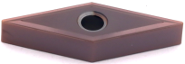 |  | VNMG160404-MS |  | MS3015 |  | Carbide |  | PVD |  | Normal Steel, S.S
71 |  |  |  | VNMG160408-MS |  | MS3015 |  | Carbide |  | PVD |  | Normal Steel, S.S
72 |  | 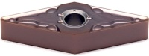 |  | VNMG160404-SL |  | MS3015 |  | Carbide |  | PVD |  | Normal Steel, S.S
73 |  |  |  | VNMG160408-SL |  | MS3015 |  | Carbide |  | PVD |  | Normal Steel, S.S
74 |  | 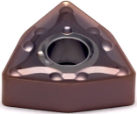 |  | WNMG06T312-SL |  | MS3015 |  | Carbide |  | PVD |  | Normal Steel, S.S
75 |  |  |  | WNMG080404-SL |  | MS3015 |  | Carbide |  | PVD |  | Normal Steel, S.S
76 |  |  |  | WNMG080408-SL |  | MS3015 |  | Carbide |  | PVD |  | Normal Steel, S.S
77 |  |  |  | WNMG080412-SL |  | MS3015 |  | Carbide |  | PVD |  | Normal Steel, S.S
78 |  | 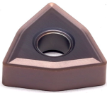 |  | WNMG080404-MS |  | MS3015 |  | Carbide |  | PVD |  | Normal Steel, S.S
79 |  |  |  | WNMG080408-MS |  | MS3015 |  | Carbide |  | PVD |  | Normal Steel, S.S
Grade: MS3015
PVD (TiN+TiCN) is suitable for high-precision processing of stainless steel and low carbon steel, with excellent sharpness and solubility.
Carbide Inserts-KLY Series
No. | Reference  Photo |  | Type |  | Grade |  | Material |  | Coating |  | Work-piece Materials
1 | 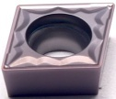 |  | CCMT060204-HMP |  | MS3035 |  | Carbide |  | PVD |  | Normal Steel, S.S
2 |  |  | CCMT060208-HMP |  | MS3035 |  | Carbide |  | PVD |  | Normal Steel, S.S
3 |  |  | CCMT09T302-HMP |  | MS3035 |  | Carbide |  | PVD |  | Normal Steel, S.S
4 |  |  | CCMT09T304-HMP |  | MS3035 |  | Carbide |  | PVD |  | Normal Steel, S.S
5 |  |  | CCMT09T308-HMP |  | MS3035 |  | Carbide |  | PVD |  | Normal Steel, S.S
6 |  |  | CCMT120404-HMP |  | MS3035 |  | Carbide |  | PVD |  | Normal Steel, S.S
7 |  |  | CCMT120408-HMP |  | MS3035 |  | Carbide |  | PVD |  | Normal Steel, S.S
8 | 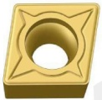 |  | CCMT120404-C25 |  | MS3035 |  | Carbide |  | PVD |  | Normal Steel, S.S
9 |  |  | CCMT120408-C25 |  | MS3035 |  | Carbide |  | PVD |  | Normal Steel, S.S
10 | 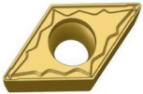 |  | DCMT070204-HMP |  | MS3035 |  | Carbide |  | PVD |  | Normal Steel, S.S
11 |  |  | DCMT11T304-HMP |  | MS3035 |  | Carbide |  | PVD |  | Normal Steel, S.S
12 |  |  | DCMT11T308-HMP |  | MS3035 |  | Carbide |  | PVD |  | Normal Steel, S.S
13 | 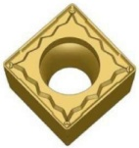 |  | SCMT09T304-HMP |  | MS3035 |  | Carbide |  | PVD |  | Normal Steel, S.S
14 | 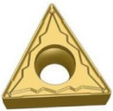 |  | TCMT16T304-HMP |  | MS3035 |  | Carbide |  | PVD |  | Normal Steel, S.S
15 |  |  | TCMT16T308-HMP |  | MS3035 |  | Carbide |  | PVD |  | Normal Steel, S.S
16 | 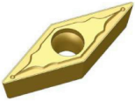 |  | VBMT160404-HMP |  | MS3035 |  | Carbide |  | PVD |  | Normal Steel, S.S
17 |  |  | VBMT160408-HMP |  | MS3035 |  | Carbide |  | PVD |  | Normal Steel, S.S
18 | 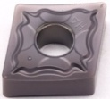 |  | CNMG120404-HA |  | MS3035 |  | Carbide |  | PVD |  | Normal Steel, S.S
19 |  |  | CNMG120408-HA |  | MS3035 |  | Carbide |  | PVD |  | Normal Steel, S.S
20 | 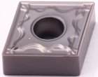 |  | CNMG120404-HM |  | MS3035 |  | Carbide |  | PVD |  | Normal Steel, S.S
21 |  |  | CNMG120408-HM |  | MS3035 |  | Carbide |  | PVD |  | Normal Steel, S.S
22 | 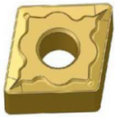 |  | CNMG120408-GS |  | MS3035 |  | Carbide |  | PVD |  | Normal Steel, S.S
23 | 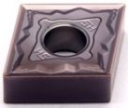 |  | CNMG120404-HS |  | MS3035 |  | Carbide |  | PVD |  | Normal Steel, S.S
24 |  |  | CNMG120408-HS |  | MS3035 |  | Carbide |  | PVD |  | Normal Steel, S.S
25 | 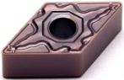 |  | DNMG150604-HM |  | MS3035 |  | Carbide |  | PVD |  | Normal Steel, S.S
26 |  |  | DNMG150608-HM |  | MS3035 |  | Carbide |  | PVD |  | Normal Steel, S.S
27 | 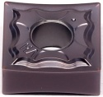 |  | SNMG120404-HA |  | MS3035 |  | Carbide |  | PVD |  | Normal Steel, S.S
28 |  |  | SNMG120408-HA |  | MS3035 |  | Carbide |  | PVD |  | Normal Steel, S.S
29 | 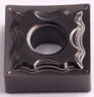 |  | SNMG120404-HM |  | MS3035 |  | Carbide |  | PVD |  | Normal Steel, S.S
30 |  |  | SNMG120408-HM |  | MS3035 |  | Carbide |  | PVD |  | Normal Steel, S.S
31 | 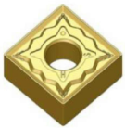 |  | SNMG120404-HS |  | MS3035 |  | Carbide |  | PVD |  | Normal Steel, S.S
32 |  |  | SNMG120408-HS |  | MS3035 |  | Carbide |  | PVD |  | Normal Steel, S.S
33 | 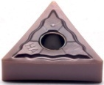 |  | TNMG160404-HA |  | MS3035 |  | Carbide |  | PVD |  | Normal Steel, S.S
34 |  |  | TNMG160408-HA |  | MS3035 |  | Carbide |  | PVD |  | Normal Steel, S.S
35 | 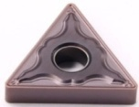 |  | TNMG160404-HM |  | MS3035 |  | Carbide |  | PVD |  | Normal Steel, S.S
36 |  |  | TNMG160408-HM |  | MS3035 |  | Carbide |  | PVD |  | Normal Steel, S.S
37 |  |  | TNMG160412-HM |  | MS3035 |  | Carbide |  | PVD |  | Normal Steel, S.S
38 |  |  | TNMG220404-HM |  | MS3035 |  | Carbide |  | PVD |  | Normal Steel, S.S
39 |  |  | TNMG220408-HM |  | MS3035 |  | Carbide |  | PVD |  | Normal Steel, S.S
40 | 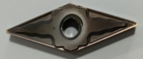 |  | VNMG160404-HM |  | MS3035 |  | Carbide |  | PVD |  | Normal Steel, S.S
41 |  |  | VNMG160408-HM |  | MS3035 |  | Carbide |  | PVD |  | Normal Steel, S.S
42 | 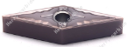 |  | VNMG160404-HS |  | MS3035 |  | Carbide |  | PVD |  | Normal Steel, S.S
44 | 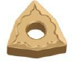 |  | WNMG080404-GS |  | MS3035 |  | Carbide |  | PVD |  | Normal Steel, S.S
45 |  |  | WNMG080408-GS |  | MS3035 |  | Carbide |  | PVD |  | Normal Steel, S.S
46 | 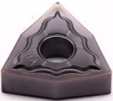 |  | WNMG080404-HA |  | MS3035 |  | Carbide |  | PVD |  | Normal Steel, S.S
47 |  |  | WNMG080408-HA |  | MS3035 |  | Carbide |  | PVD |  | Normal Steel, S.S
48 | 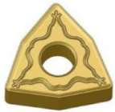 |  | WNMG080404-HM |  | MS3035 |  | Carbide |  | PVD |  | Normal Steel, S.S
49 |  |  | WNMG080408-HM |  | MS3035 |  | Carbide |  | PVD |  | Normal Steel, S.S
50 | 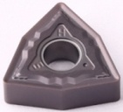 |  | WNMG080404-HS |  | MS3035 |  | Carbide |  | PVD |  | Normal Steel, S.S
51 |  |  | WNMG080408-HS |  | MS3035 |  | Carbide |  | PVD |  | Normal Steel, S.S
Grade: MS3015
PVD (TiN+TiCN) is suitable for high-precision processing of stainless steel and low carbon steel, with excellent sharpness and solubility.
Grade: MS3035
PVD (TiAlSiN)
High Co content and fine WC grain substrate, combine with good thermal stability silicon coating, it has low friction coefficient and good hardness, suitable for grooving of steel and stainless steel.

