- Cermet Full Ground Inserts
All-ground Cermet Inserts, Fine Boring & Fine Turning
Turning & boring-SL, Turning & boring-JC, Turning & boring-DZ
Full-grinded Cermet Inserts-SL Series
No. | Reference  Photo | Type | Grade | Material | Coating | Work-piece  Materials
1 | 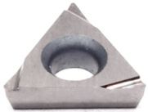 | TPGH080202L-FE | T25A | Cermet | Uncoated | Steel
2 |  | TPGH080204L-FE | T25A | Cermet | Uncoated | Steel
3 |  | TPGH090202L-FE | T25A | Cermet | Uncoated | Steel
4 |  | TPGH090204L-FE | T25A | Cermet | Uncoated | Steel
5 |  | TPGH110302L-FE | T25A | Cermet | Uncoated | Steel
6 |  | TPGH110304L-FE | T25A | Cermet | Uncoated | Steel
7 | 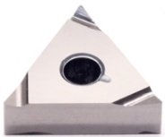 | TNGG160402L-FE | T25A | Cermet | Uncoated | Steel
8 |  | TNGG160402R-FE | T25A | Cermet | Uncoated | Steel
9 |  | TNGG160404L-FE | T25A | Cermet | Uncoated | Steel
10 |  | TNGG160404R-FE | T25A | Cermet | Uncoated | Steel
11 | 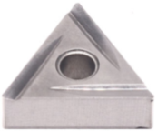 | TNGG160404R-2G | T25A | Cermet | Uncoated | Steel
12 |  | TNMG160404R-2G | T25A | Cermet | Uncoated | Steel
Full-grinded Cermet Inserts-JC Series
No. | Reference  Photo | Type | Grade | Material | Coating | Work-piece  Materials
1 | 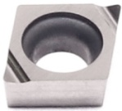 | CCGT030101L-F | T25A | Cermet | Uncoated | Steel
2 |  | CCGT030102L-F | T25A | Cermet | Uncoated | Steel
3 |  | CCGT030104L-F | T25A | Cermet | Uncoated | Steel
4 |  | CCGT040101L-F | T25A | Cermet | Uncoated | Steel
5 |  | CCGT040102L-F | T25A | Cermet | Uncoated | Steel
6 |  | CCGT040104L-F | T25A | Cermet | Uncoated | Steel
7 |  | CCGT060202L-F | T25A | Cermet | Uncoated | Steel
8 |  | CCGT060204L-F | T25A | Cermet | Uncoated | Steel
9 | 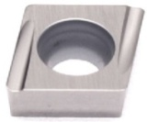 | CCGT060201EL-U | T25A | Cermet | Uncoated | Steel
10 |  | CCGT060202EL-U | T25A | Cermet | Uncoated | Steel
11 |  | CCGT060202ER-U | T25A | Cermet | Uncoated | Steel
12 |  | CCGT060204EL-U | T25A | Cermet | Uncoated | Steel
13 |  | CCGT060204ER-U | T25A | Cermet | Uncoated | Steel
14 |  | CCGT09T301EL-U | T25A | Cermet | Uncoated | Steel
15 |  | CCGT09T302EL-U | T25A | Cermet | Uncoated | Steel
16 |  | CCGT09T302ER-U | T25A | Cermet | Uncoated | Steel
17 |  | CCGT09T304EL-U | T25A | Cermet | Uncoated | Steel
18 |  | CCGT09T304ER-U | T25A | Cermet | Uncoated | Steel
19 | 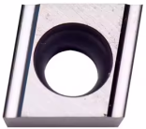 | CCGT060202L-H | T25A | Cermet | Uncoated | Steel
20 |  | CCGT060204L-H | T25A | Cermet | Uncoated | Steel
21 |  | CCGT09T302L-H | T25A | Cermet | Uncoated | Steel
22 |  | CCGT09T304L-H | T25A | Cermet | Uncoated | Steel
23 | 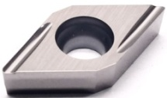 | DCGT070202EL-U | T25A | Cermet | Uncoated | Steel
24 |  | DCGT070202ER-U | T25A | Cermet | Uncoated | Steel
25 |  | DCGT070204EL-U | T25A | Cermet | Uncoated | Steel
26 |  | DCGT070204ER-U | T25A | Cermet | Uncoated | Steel
27 |  | DCGT11T301EL-U | T25A | Cermet | Uncoated | Steel
28 |  | DCGT11T301ER-U | T25A | Cermet | Uncoated | Steel
29 |  | DCGT11T302ER-U | T25A | Cermet | Uncoated | Steel
30 |  | DCGT11T302EL-U | T25A | Cermet | Uncoated | Steel
31 |  | DCGT11T304EL-U | T25A | Cermet | Uncoated | Steel
32 |  | DCGT11T304ER-U | T25A | Cermet | Uncoated | Steel
33 |  | DCGT11T302FL-U | T25A | Cermet | Uncoated | Steel
34 |  | DCGT11T304FR-U | T25A | Cermet | Uncoated | Steel
35 | 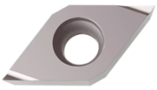 | DCGT11T302R-F | T25A | Cermet | Uncoated | Steel
36 |  | DCGT11T304R-F | T25A | Cermet | Uncoated | Steel
37 | 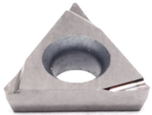 | TBGT060101L | T25A | Cermet | Uncoated | Steel
38 |  | TBGT060102L | T25A | Cermet | Uncoated | Steel
39 |  | TBGT060104L | T25A | Cermet | Uncoated | Steel
40 |  | TCGT060102L | T25A | Cermet | Uncoated | Steel
41 |  | TCGT060104L | T25A | Cermet | Uncoated | Steel
42 |  | TCGT110202L | T25A | Cermet | Uncoated | Steel
43 |  | TCGT110204L | T25A | Cermet | Uncoated | Steel
44 |  | TCGT110202L-L2 | T25A | Cermet | Uncoated | Steel
45 |  | TCGT110204L-L2 | T25A | Cermet | Uncoated | Steel
46 |  | TPGH080201L | T25A | Cermet | Uncoated | Steel
47 |  | TPGH080202L | T25A | Cermet | Uncoated | Steel
48 |  | TPGH080204L | T25A | Cermet | Uncoated | Steel
49 |  | TPGH090201L | T25A | Cermet | Uncoated | Steel
50 |  | TPGH090202L | T25A | Cermet | Uncoated | Steel
51 |  | TPGH090204L | T25A | Cermet | Uncoated | Steel
52 |  | TPGH110301L | T25A | Cermet | Uncoated | Steel
53 |  | TPGH110302L | T25A | Cermet | Uncoated | Steel
54 |  | TPGH110304L | T25A | Cermet | Uncoated | Steel
55 | 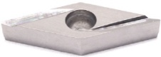 | VBGT110301L-Y | T25A | Cermet | Uncoated | Steel
56 |  | VBGT110301R-Y | T25A | Cermet | Uncoated | Steel
57 |  | VBGT110302L-Y | T25A | Cermet | Uncoated | Steel
58 |  | VBGT110302R-Y | T25A | Cermet | Uncoated | Steel
59 |  | VBGT110304L-Y | T25A | Cermet | Uncoated | Steel
60 |  | VBGT110304R-Y | T25A | Cermet | Uncoated | Steel
61 |  | VBGT160402L-Y | T25A | Cermet | Uncoated | Steel
62 |  | VBGT160402R-Y | T25A | Cermet | Uncoated | Steel
63 |  | VBGT160404L-Y | T25A | Cermet | Uncoated | Steel
64 |  | VBGT160404R-Y | T25A | Cermet | Uncoated | Steel
65 | 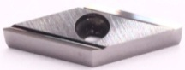 | VBGT110302L-H | T25A | Cermet | Uncoated | Steel
66 |  | VBGT110302R-H | T25A | Cermet | Uncoated | Steel
67 |  | VBGT110304L-H | T25A | Cermet | Uncoated | Steel
68 |  | VBGT110304R-H | T25A | Cermet | Uncoated | Steel
69 | 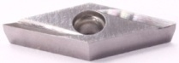 | VBGT110302R-F | T25A | Cermet | Uncoated | Steel
70 |  | VBGT110304R-F | T25A | Cermet | Uncoated | Steel
71 | 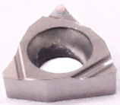 | WBGT060102L-F | T25A | Cermet | Uncoated | Steel
72 |  | WBGT060104L-F | T25A | Cermet | Uncoated | Steel
73 | 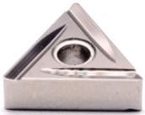 | TNMG160404L-C | T25A | Cermet | Uncoated | Steel
74 |  | TNMG160404R-C | T25A | Cermet | Uncoated | Steel
75 |  | TNMG160408L-C | T25A | Cermet | Uncoated | Steel
76 |  | TNMG160408R-C | T25A | Cermet | Uncoated | Steel
77 | 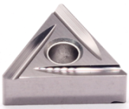 | TNGG160402L-C | T25A | Cermet | Uncoated | Steel
78 |  | TNGG160402R-C | T25A | Cermet | Uncoated | Steel
79 |  | TNGG160404L-C | T25A | Cermet | Uncoated | Steel
80 |  | TNGG160404R-C | T25A | Cermet | Uncoated | Steel
81 | 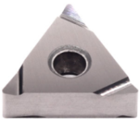 | TNGG160402L-S | T25A | Cermet | Uncoated | Steel
82 |  | TNGG160402R-S | T25A | Cermet | Uncoated | Steel
83 |  | TNGG160404L-S | T25A | Cermet | Uncoated | Steel
84 |  | TNGG160404R-S | T25A | Cermet | Uncoated | Steel
85 |  | TNGG160408L-S | T25A | Cermet | Uncoated | Steel
86 |  | TNGG160408R-S | T25A | Cermet | Uncoated | Steel
87 | 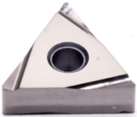 | TNGG160402L-W | T25A | Cermet | Uncoated | Steel
88 |  | TNGG160402R-W | T25A | Cermet | Uncoated | Steel
89 |  | TNGG160404L-W | T25A | Cermet | Uncoated | Steel
90 |  | TNGG160404R-W | T25A | Cermet | Uncoated | Steel
91 |  | TNGG160408L-W | T25A | Cermet | Uncoated | Steel
92 |  | TNGG160408R-W | T25A | Cermet | Uncoated | Steel
Full-grinded Cermet Inserts-DZ Series
No. | Reference  Photo | Type | Grade | Material | Coating | Work-piece  Materials
1 | 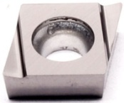 | CCGT060202L-W15 | T25A | Cermet | Uncoated | Steel
2 |  | CCGT060202R-W15 | T25A | Cermet | Uncoated | Steel
3 |  | CCGT060204L-W15 | T25A | Cermet | Uncoated | Steel
4 |  | CCGT060204R-W15 | T25A | Cermet | Uncoated | Steel
5 |  | CCGT09T302L-W20 | T25A | Cermet | Uncoated | Steel
6 |  | CCGT09T304L-W20 | T25A | Cermet | Uncoated | Steel
7 |  | CCGT09T308L-W20 | T25A | Cermet | Uncoated | Steel
8 | 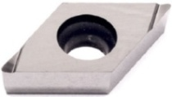 | DCGT070202L-W10 | T25A | Cermet | Uncoated | Steel
9 |  | DCGT070202R-W10 | T25A | Cermet | Uncoated | Steel
10 |  | DCGT070204L-W10 | T25A | Cermet | Uncoated | Steel
11 |  | DCGT070204R-W10 | T25A | Cermet | Uncoated | Steel
12 |  | DCGT11T302L-W15 | T25A | Cermet | Uncoated | Steel
13 |  | DCGT11T302R-W15 | T25A | Cermet | Uncoated | Steel
14 |  | DCGT11T304L-W15 | T25A | Cermet | Uncoated | Steel
15 |  | DCGT11T304R-W15 | T25A | Cermet | Uncoated | Steel
16 |  | DCGT11T301FR-J10 | T25A | Cermet | Uncoated | Steel
17 |  | DCGT11T302FR-J10 | T25A | Cermet | Uncoated | Steel
18 |  | DCGT11T304FR-J10 | T25A | Cermet | Uncoated | Steel
19 | 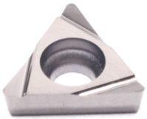 | TCGT110202L-W15 | T25A | Cermet | Uncoated | Steel
20 |  | TCGT110204L-W15 | T25A | Cermet | Uncoated | Steel
21 |  | TPGT080204L-W08 | T25A | Cermet | Uncoated | Steel
22 |  | TPGT090202L-W15 | T25A | Cermet | Uncoated | Steel
23 |  | TPGT090204L-W15 | T25A | Cermet | Uncoated | Steel
24 |  | TPGT110202L-W15 | T25A | Cermet | Uncoated | Steel
25 |  | TPGT110204L-W15 | T25A | Cermet | Uncoated | Steel
26 |  | TPGT110304L-W15 | T25A | Cermet | Uncoated | Steel
27 | 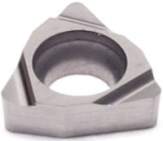 | WBGT030102L-W08 | T25A | Cermet | Uncoated | Steel
28 |  | WBGT030104L-W08 | T25A | Cermet | Uncoated | Steel
29 |  | WBGT060102L-W11 | T25A | Cermet | Uncoated | Steel
30 |  | WBGT060104L-W11 | T25A | Cermet | Uncoated | Steel
31 |  | WBGT080202L-W11 | T25A | Cermet | Uncoated | Steel
32 |  | WBGT080204L-W11 | T25A | Cermet | Uncoated | Steel
33 | 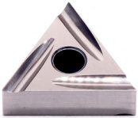 | TNGG160402L-P | T25A | Cermet | Uncoated | Steel
34 |  | TNGG160402R-P | T25A | Cermet | Uncoated | Steel
35 |  | TNGG160404L-P | T25A | Cermet | Uncoated | Steel
36 |  | TNGG160404R-P | T25A | Cermet | Uncoated | Steel
37 |  | TNGG160408L-P | T25A | Cermet | Uncoated | Steel
38 |  | TNGG160408R-P | T25A | Cermet | Uncoated | Steel
39 | 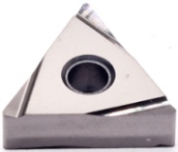 | TNGG160402L-W | T25A | Cermet | Uncoated | Steel
40 |  | TNGG160402R-W | T25A | Cermet | Uncoated | Steel
41 |  | TNGG160404L-W | T25A | Cermet | Uncoated | Steel
42 |  | TNGG160404R-W | T25A | Cermet | Uncoated | Steel
43 |  | TNGG160408L-W | T25A | Cermet | Uncoated | Steel
44 | 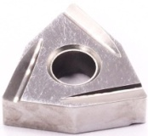 | WNMG080404L-CG | T25A | Cermet | Uncoated | Steel
45 |  | WNMG080404R-CG | T25A | Cermet | Uncoated | Steel
Grade: T25A
TiCN based cermet material, with strong crater wear resistance and can withstand certain impact loads, suitable for finishing of low-carbon steel, low-alloy steel, gray cast iron, silicon-aluminum alloy and stainless steel.

