Carbide Inserts for Railway Hub
Application:
Railway hub insert is a tool specially made for processing railway wheels. These tools are often grouped into groups, such as "new" wheel tools for machining new cast and forged wheels, or tools for machining old wheels (train wheel reconditioning and finishing turning).
Railway Wheel Hub Inserts
No. | Reference  Photo | Type | Grade | Material | Coating | Work-piece  Materials
1 | 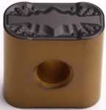 | LNMX191940-53 | TBC2015 | Carbide | CVD | Steel
2 | 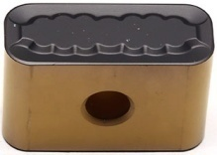 | LNMX301940-MF | TBC2015 | Carbide | CVD | Steel
3 | 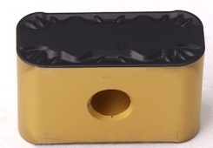 | LNMX301940-34 | TBC2015 | Carbide | CVD | Steel
4 | 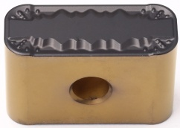 | LNMX301940-53 | TBC2015 | Carbide | CVD | Steel
5 | 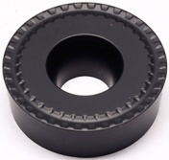 | RCMT2006MO-53 | TBC2025 | Carbide | CVD | Steel
6 | 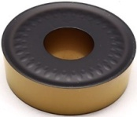 | RCGT2508-53 | TBC2015 | Carbide | CVD | Steel
7 |  | RCET3009MO-53 | TBC2015 | Carbide | CVD | Steel
8 | 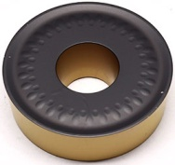 | RCGT3209-53 | TBC2015 | Carbide | CVD | Steel
9 | 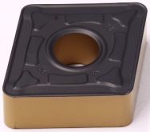 | CNMG250924-PR | TBC2015 | Carbide | CVD | Steel
10 | 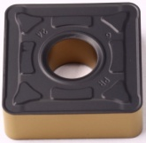 | SNMG250724-PR | TBC2015 | Carbide | CVD | Steel
Grade: TBC2015
CVD (Ti CN + thick Al₂0₃) coating, the highly wear-resistant coating, combined with the substrate, is the preferred grade for finishing to rough processing of steel parts, and also reflects a high metal removal rate in interrupted processing.
Grade: TBC2025
Better wear resistance and fracture resistance due to thick Al₂O₃, for roughing and semi-finishing.

Recommended Cutting Parameters
Insert Type | Ap | F | Vc
R-53 | 1.0-7.0 | 0.45-1.5 | 60-12.
LNMX | 2.0-11.0 | 0.75-1.8 | 50-100
PR | 2.0-14.0 | 0.4-1.2 | 190-295

