Carbide Grooving Inserts
The application of cutting and grooving includes outer circle grooving, outer circle cutting, inner hole grooving, end face grooving and tool withdrawal grooving, etc. The grooving shapes include narrow grooves, wide grooves, shallow grooves, deep grooves and forming grooves. These series of inserts are mainly PVD coated, for processing steel parts and stainless steel.
Carbide Grooving Inserts
No. | Reference Photo | Type | Grade | Material | Coating | Work-piece  Materials
1 | 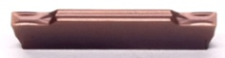 | MGMN150-G | MS3035 | Carbide | PVD | Steel, S.S
2 |  | MGMN200-G | MS3035 | Carbide | PVD | Steel, S.S
3 | 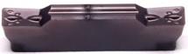 | MGMN250-M | MS3035 | Carbide | PVD | Steel, S.S
4 |  | MGMN300-M | MS3035 | Carbide | PVD | Steel, S.S
5 |  | MGMN400-M | MS3035 | Carbide | PVD | Steel, S.S
6 |  | MGMN500-M | MS3035 | Carbide | PVD | Steel, S.S
7 |  | MGMN600-M | MS3035 | Carbide | PVD | Steel, S.S
8 | 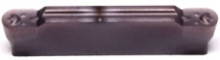 | MRMN200-G | MS3035 | Carbide | PVD | Steel, S.S
9 |  | MRMN300-M | MS3035 | Carbide | PVD | Steel, S.S
10 |  | MRMN400-M | MS3035 | Carbide | PVD | Steel, S.S
11 |  | MRMN500-M | MS3035 | Carbide | PVD | Steel, S.S
12 | 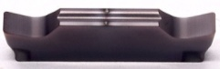 | MGGN150 | MS3035 | Carbide | PVD | Steel, S.S
13 |  | MGGN200 | MS3035 | Carbide | PVD | Steel, S.S
14 |  | MGGN300 | MS3035 | Carbide | PVD | Steel, S.S
15 |  | MGGN400 | MS3035 | Carbide | PVD | Steel, S.S
16 |  | MGGN500 | MS3035 | Carbide | PVD | Steel, S.S
17 |  | MGGN600 | MS3035 | Carbide | PVD | Steel, S.S
18 | 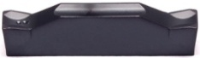 | TDC2 | MS3030 | Carbide | PVD | Steel, S.S
19 |  | TDC3 | MS3030 | Carbide | PVD | Steel, S.S
20 |  | TDC4 | MS3030 | Carbide | PVD | Steel, S.S
21 | 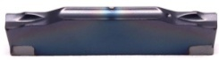 | TDJ2 | MS3030 | Carbide | PVD | Steel, S.S
22 |  | TDJ3 | MS3030 | Carbide | PVD | Steel, S.S
23 | 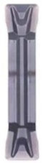 | MGMN200-T | MS3030 | Carbide | PVD | Steel, S.S
24 |  | MGMN250-T | MS3030 | Carbide | PVD | Steel, S.S
25 |  | MGMN300-T | MS3030 | Carbide | PVD | Steel, S.S
26 |  | MGMN400-T | MS3030 | Carbide | PVD | Steel, S.S
27 | 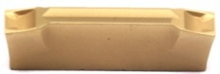 | WGE20 | MS3020 | Carbide | PVD | Steel, S.S
28 |  | WGE30 | MS3020 | Carbide | PVD | Steel, S.S
29 |  | WGE40 | MS3020 | Carbide | PVD | Steel, S.S
30 |  | WGE50 | MS3020 | Carbide | PVD | Steel, S.S
31 | 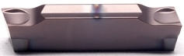 | GMX2020-C | MS3050 | Carbide | PVD | Steel, S.S
32 |  | GMX3020-C | MS3050 | Carbide | PVD | Steel, S.S
33 | 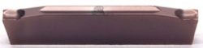 | GMP1520-A | MS3050 | Carbide | PVD | Steel, S.S
34 |  | GMP200-A | MS3050 | Carbide | PVD | Steel, S.S
35 | 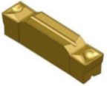 | N123K2-0600-0004-ST | TBC2015 | Carbide | CVD | Steel
36 | 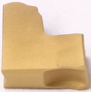 | TAG2 | MS3005 | Carbide | PVD | Steel, S.S
37 |  | TAG3 | MS3005 | Carbide | PVD | Steel, S.S
38 |  | TAG4 | MS3005 | Carbide | PVD | Steel, S.S
39 |  | TAG5 | MS3005 | Carbide | PVD | Steel, S.S
40 | 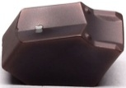 | TL1402 | MS3035 | Carbide | PVD | Steel, S.S
41 |  | TL1403 | MS3035 | Carbide | PVD | Steel, S.S
42 |  | TL1404 | MS3035 | Carbide | PVD | Steel, S.S
43 |  | TL1405 | MS3035 | Carbide | PVD | Steel, S.S
44 |  | TL1406 | MS3035 | Carbide | PVD | Steel, S.S
45 | 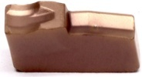 | KT300 | MS3015 | Carbide | PVD | Steel, S.S
46 |  | KT400 | MS3015 | Carbide | PVD | Steel, S.S
47 |  | KT500 | MS3015 | Carbide | PVD | Steel, S.S
48 | 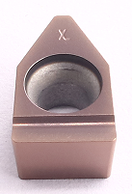 | FBMT120805 | MS1050 | Carbide | PVD | Steel, S.S
49 | 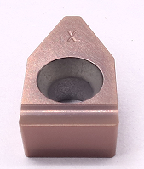 | FBMT151005 | MS1050 | Carbide | PVD | Steel, S.S
50 | 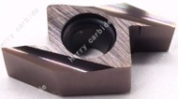 | ABS15R4005 | MS1050 | Carbide | PVD | Steel, S.S
Grade: MS3035
High Co content and fine WC grain substrate, combine with good thermal stability silicon coating, it has low friction coefficient and good hardness, suitable for grooving of steel and stainless steel.
Grade: MS3030
High Co content and fine WC grain substrate, combine with PVD AlTiN coating, which has outstanding wear resistance. Suitable for steel and stainless steel drilling.
Grade: MS3050
High Co content and fine WC grain substrate, combine with good thermal stability silicon coating, it has low friction coefficient and good hardness, which is very suitable for miniatures of steel and stainless steel that has high requirement for surface finish.
Grade: MS1050
Ultra-fine-grain WC substrate combined with silicon-containing coating, suitable for fine turning and boring of steel and stainless steel.

