Carbide Inserts for Aluminum Alloy
Aluminum processing tool materials generally use fine grain YG carbide (ISOK10--K20), polycrystalline composite diamond (PCD, also known as diamond sintering body) and natural diamond, etc., which are suitable for cutting aluminum alloy tool materials, can ensure that the tool edge is sharp and wear-resistant. AL groove with aluminum processing special material CWK001, the use of fine crystal carbide, excellent wear resistance, and good tool edge chipping resistance, suitable for aluminum alloy and other non-ferrous metal semi-finishing to high-speed finishing.
Carbide Inserts for Aluminum Alloy
No. | Reference  Photo | Type | Grade | Material | Coating | Work-piece  Materials
1 | 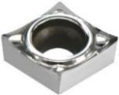 | CCGT060202-AL | K10-1 | Carbide | Uncoated | Aluminum alloy
2 |  | CCGT060204-AL | K10-1 | Carbide | Uncoated | Aluminum alloy
3 |  | CCGT060208-AL | K10-1 | Carbide | Uncoated | Aluminum alloy
4 | 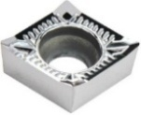 | CCGT09T302-AL | K10-1 | Carbide | Uncoated | Aluminum alloy
5 |  | CCGT09T304-AL | K10-1 | Carbide | Uncoated | Aluminum alloy
6 |  | CCGT09T308-AL | K10-1 | Carbide | Uncoated | Aluminum alloy
7 | 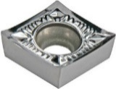 | CCGT120402-AL | K10-1 | Carbide | Uncoated | Aluminum alloy
8 |  | CCGT120404-AL | K10-1 | Carbide | Uncoated | Aluminum alloy
9 |  | CCGT120408-AL | K10-1 | Carbide | Uncoated | Aluminum alloy
10 | 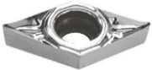 | DCGT070202-AL | K10-1 | Carbide | Uncoated | Aluminum alloy
11 |  | DCGT070204-AL | K10-1 | Carbide | Uncoated | Aluminum alloy
12 |  | DCGT070208-AL | K10-1 | Carbide | Uncoated | Aluminum alloy
13 | 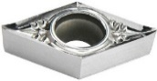 | DCGT11T301-AL | K10-1 | Carbide | Uncoated | Aluminum alloy
14 |  | DCGT11T302-AL | K10-1 | Carbide | Uncoated | Aluminum alloy
15 |  | DCGT11T304-AL | K10-1 | Carbide | Uncoated | Aluminum alloy
16 |  | DCGT11T308-AL | K10-1 | Carbide | Uncoated | Aluminum alloy
17 | 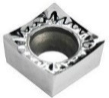 | SCGT09T302-AL | K10-1 | Carbide | Uncoated | Aluminum alloy
18 |  | SCGT09T304-AL | K10-1 | Carbide | Uncoated | Aluminum alloy
19 |  | SCGT09T308-AL | K10-1 | Carbide | Uncoated | Aluminum alloy
20 | 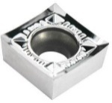 | SCGT120404-AL | K10-1 | Carbide | Uncoated | Aluminum alloy
21 |  | SCGT120408-AL | K10-1 | Carbide | Uncoated | Aluminum alloy
22 | 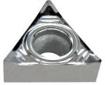 | TCGT090202-AL | K10-1 | Carbide | Uncoated | Aluminum alloy
23 |  | TCGT090204-AL | K10-1 | Carbide | Uncoated | Aluminum alloy
24 | 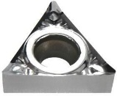 | TCGT110202-AL | K10-1 | Carbide | Uncoated | Aluminum alloy
25 |  | TCGT110204-AL | K10-1 | Carbide | Uncoated | Aluminum alloy
26 |  | TCGT110208-AL | K10-1 | Carbide | Uncoated | Aluminum alloy
27 | 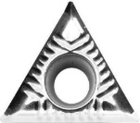 | TCGT16T302-AL | K10-1 | Carbide | Uncoated | Aluminum alloy
28 |  | TCGT16T304-AL | K10-1 | Carbide | Uncoated | Aluminum alloy
29 |  | TCGT16T308-AL | K10-1 | Carbide | Uncoated | Aluminum alloy
30 | 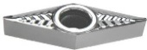 | VBGT110302-AL | K10-1 | Carbide | Uncoated | Aluminum alloy
31 |  | VBGT110304-AL | K10-1 | Carbide | Uncoated | Aluminum alloy
32 |  | VBGT110308-AL | K10-1 | Carbide | Uncoated | Aluminum alloy
33 |  | VCGT110302-AL | K10-1 | Carbide | Uncoated | Aluminum alloy
34 |  | VCGT110304-AL | K10-1 | Carbide | Uncoated | Aluminum alloy
35 |  | VCGT110308-AL | K10-1 | Carbide | Uncoated | Aluminum alloy
36 | 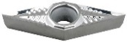 | VBGT160402-AL | K10-1 | Carbide | Uncoated | Aluminum alloy
37 |  | VBGT160404-AL | K10-1 | Carbide | Uncoated | Aluminum alloy
38 |  | VBGT160408-AL | K10-1 | Carbide | Uncoated | Aluminum alloy
39 |  | VCGT160402-AL | K10-1 | Carbide | Uncoated | Aluminum alloy
40 |  | VCGT160404-AL | K10-1 | Carbide | Uncoated | Aluminum alloy
41 |  | VCGT160408-AL | K10-1 | Carbide | Uncoated | Aluminum alloy
42 |  | VCGT160412-AL | K10-1 | Carbide | Uncoated | Aluminum alloy
43 | 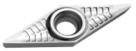 | VCGT160402-LH | K10-1 | Carbide | Uncoated | Aluminum alloy
44 |  | VCGT160404-LH | K10-1 | Carbide | Uncoated | Aluminum alloy
45 |  | VCGT160408-LH | K10-1 | Carbide | Uncoated | Aluminum alloy
46 | 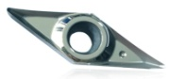 | VCGT160402-W | K10-1 | Carbide | Uncoated | Wood
47 |  | VCGT160404-W | K10-1 | Carbide | Uncoated | Wood
48 | 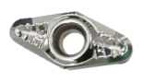 | VCGT220530 | K10-1 | Carbide | Uncoated | Aluminum alloy
49 | 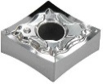 | CNMG120402-HA | K10-1 | Carbide | Uncoated | Aluminum alloy
50 |  | CNMG120404-HA | K10-1 | Carbide | Uncoated | Aluminum alloy
51 |  | CNMG120408-HA | K10-1 | Carbide | Uncoated | Aluminum alloy
52 | 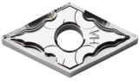 | DNMG150404-HA | K10-1 | Carbide | Uncoated | Aluminum alloy
53 |  | DNMG150408-HA | K10-1 | Carbide | Uncoated | Aluminum alloy
54 |  | DNMG150604-HA | K10-1 | Carbide | Uncoated | Aluminum alloy
55 |  | DNMG150608-HA | K10-1 | Carbide | Uncoated | Aluminum alloy
56 | 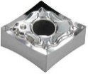 | SNMG120404-HA | K10-1 | Carbide | Uncoated | Aluminum alloy
57 |  | SNMG120408-HA | K10-1 | Carbide | Uncoated | Aluminum alloy
58 | 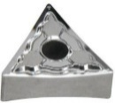 | TNMG160402-AL | K10-1 | Carbide | Uncoated | Aluminum alloy
59 |  | TNMG160404-HA | K10-1 | Carbide | Uncoated | Aluminum alloy
60 |  | TNMG160408-HA | K10-1 | Carbide | Uncoated | Aluminum alloy
61 | 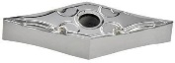 | VNMG160401-HA | K10-1 | Carbide | Uncoated | Aluminum alloy
62 |  | VNMG160402-HA | K10-1 | Carbide | Uncoated | Aluminum alloy
63 |  | VNMG160404-HA | K10-1 | Carbide | Uncoated | Aluminum alloy
64 |  | VNMG160408-HA | K10-1 | Carbide | Uncoated | Aluminum alloy
65 | 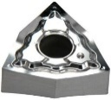 | WNMG080402-HA | K10-1 | Carbide | Uncoated | Aluminum alloy
66 |  | WNMG080404-HA | K10-1 | Carbide | Uncoated | Aluminum alloy
67 |  | WNMG080408-HA | K10-1 | Carbide | Uncoated | Aluminum alloy
68 | 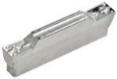 | MGMN150-G | K10-1 | Carbide | Uncoated | Aluminum alloy
69 |  | MGMN200-G | K10-1 | Carbide | Uncoated | Aluminum alloy
70 |  | MGMN250-G | K10-1 | Carbide | Uncoated | Aluminum alloy
71 |  | MGMN300-M | K10-1 | Carbide | Uncoated | Aluminum alloy
72 |  | MGMN400-M | K10-1 | Carbide | Uncoated | Aluminum alloy
73 |  | MGMN500-M | K10-1 | Carbide | Uncoated | Aluminum alloy
74 |  | MGMN600-M | K10-1 | Carbide | Uncoated | Aluminum alloy
75 | 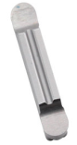 | MRGN200 | K10-1 | Carbide | Uncoated | Aluminum alloy
76 |  | MRGN300 | K10-1 | Carbide | Uncoated | Aluminum alloy
77 |  | MRGN400 | K10-1 | Carbide | Uncoated | Aluminum alloy
78 | 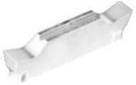 | MGGN150-G | K10-1 | Carbide | Uncoated | Aluminum alloy
79 |  | MGGN200-G | K10-1 | Carbide | Uncoated | Aluminum alloy
80 |  | MGGN250-G | K10-1 | Carbide | Uncoated | Aluminum alloy
81 |  | MGGN300-M | K10-1 | Carbide | Uncoated | Aluminum alloy
82 |  | MGGN400-M | K10-1 | Carbide | Uncoated | Aluminum alloy
83 |  | MGGN500-M | K10-1 | Carbide | Uncoated | Aluminum alloy
84 | 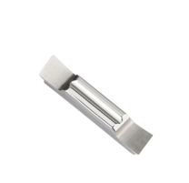 | MGGN150R-8 | K10-1 | Carbide | Uncoated | Aluminum alloy
85 |  | MGGN200R-8 | K10-1 | Carbide | Uncoated | Aluminum alloy
86 |  | MGGN250R-8 | K10-1 | Carbide | Uncoated | Aluminum alloy
87 |  | MGGN300R-8 | K10-1 | Carbide | Uncoated | Aluminum alloy
88 |  | MGGN400R-8 | K10-1 | Carbide | Uncoated | Aluminum alloy
89 |  | MGGN500R-8 | K10-1 | Carbide | Uncoated | Aluminum alloy
90 | 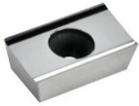 | APKT160402-MA | K10-1 | Carbide | Uncoated | Aluminum alloy
91 |  | APKT160404-MA | K10-1 | Carbide | Uncoated | Aluminum alloy
92 |  | APKT160408-MA | K10-1 | Carbide | Uncoated | Aluminum alloy
93 | 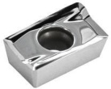 | APKT1604PDFR-MA3 | K10-1 | Carbide | Uncoated | Aluminum alloy
94 | 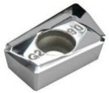 | APGT160404-G2 | K10-1 | Carbide | Uncoated | Aluminum alloy
95 |  | APGT160408-G2 | K10-1 | Carbide | Uncoated | Aluminum alloy
96 | 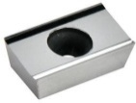 | APGT113502-MA | K10-1 | Carbide | Uncoated | Aluminum alloy
97 |  | APGT113504-MA | K10-1 | Carbide | Uncoated | Aluminum alloy
98 | 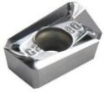 | APGT113502-G2 | K10-1 | Carbide | Uncoated | Aluminum alloy
99 |  | APGT113504-G2 | K10-1 | Carbide | Uncoated | Aluminum alloy
100 | 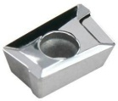 | APKT1003 | K10-1 | Carbide | Uncoated | Aluminum alloy
101 | 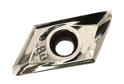 | XEKT19M508FR-MA | K10-1 | Carbide | Uncoated | Aluminum alloy
102 | 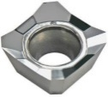 | SEHT1204 | K10-1 | Carbide | Uncoated | Aluminum alloy
103 | 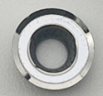 | RCGT0501-MO | K10-1 | Carbide | Uncoated | Aluminum alloy
104 |  | RCGT0702-MO | K10-1 | Carbide | Uncoated | Aluminum alloy
105 | 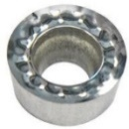 | RCGT0803-MO | K10-1 | Carbide | Uncoated | Aluminum alloy
106 |  | RCGT1003-MO | K10-1 | Carbide | Uncoated | Aluminum alloy
107 |  | RCGT10T3-MO | K10-1 | Carbide | Uncoated | Aluminum alloy
108 |  | RCGT1204-MO | K10-1 | Carbide | Uncoated | Aluminum alloy
109 |  | RCGT1605-MO | K10-1 | Carbide | Uncoated | Aluminum alloy
110 | 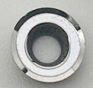 | RDGT0501-MO | K10-1 | Carbide | Uncoated | Aluminum alloy
111 |  | RDGT0702-MO | K10-1 | Carbide | Uncoated | Aluminum alloy
112 | 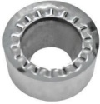 | RDGT1605-MO | K10-1 | Carbide | Uncoated | Aluminum alloy
113 | 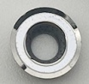 | RPGT0501-MO | K10-1 | Carbide | Uncoated | Aluminum alloy
114 |  | RPGT0702-MO | K10-1 | Carbide | Uncoated | Aluminum alloy
115 | 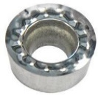 | RPGT0803-MO | K10-1 | Carbide | Uncoated | Aluminum alloy
116 |  | RPGT1003-MO | K10-1 | Carbide | Uncoated | Aluminum alloy
117 |  | RPGT10T3-MO | K10-1 | Carbide | Uncoated | Aluminum alloy
118 |  | RPGT1204-MO | K10-1 | Carbide | Uncoated | Aluminum alloy
119 |  | RPGT1605-MO | K10-1 | Carbide | Uncoated | Aluminum alloy
120 | 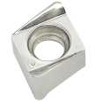 | 4NKT060308-GM | K10-1 | Carbide | Uncoated | Aluminum alloy
121 | 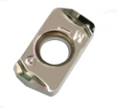 | LOGU0303-GM | K10-1 | Carbide | Uncoated | Aluminum alloy
122 | 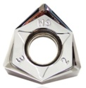 | WNMU080608-GM | K10-1 | Carbide | Uncoated | Aluminum alloy
123 | 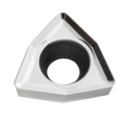 | WCKT030208 | K10-1 | Carbide | Uncoated | Aluminum alloy
124 |  | WCKT040208 | K10-1 | Carbide | Uncoated | Aluminum alloy
125 |  | WCKT050308 | K10-1 | Carbide | Uncoated | Aluminum alloy
126 |  | WCKT06T308 | K10-1 | Carbide | Uncoated | Aluminum alloy
127 |  | WCKT080412 | K10-1 | Carbide | Uncoated | Aluminum alloy
128 | 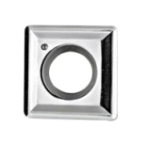 | SPGT050204 | K10-1 | Carbide | Uncoated | Aluminum alloy
129 |  | SPGT060204 | K10-1 | Carbide | Uncoated | Aluminum alloy
130 |  | SPGT07T308 | K10-1 | Carbide | Uncoated | Aluminum alloy
131 |  | SPGT090408 | K10-1 | Carbide | Uncoated | Aluminum alloy
132 |  | SPGT110408 | K10-1 | Carbide | Uncoated | Aluminum alloy
133 |  | SPGT140512 | K10-1 | Carbide | Uncoated | Aluminum alloy
134 | 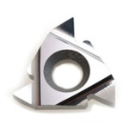 | 16ER AG55 | K10-1 | Carbide | Uncoated | Aluminum alloy
135 |  | 16ER AG60 | K10-1 | Carbide | Uncoated | Aluminum alloy
136 |  | 16ER 14W | K10-1 | Carbide | Uncoated | Aluminum alloy
137 |  | 16ER ISO100 | K10-1 | Carbide | Uncoated | Aluminum alloy
138 |  | 16ER ISO125 | K10-1 | Carbide | Uncoated | Aluminum alloy
139 |  | 16ER ISO150 | K10-1 | Carbide | Uncoated | Aluminum alloy
140 |  | 16ER ISO175 | K10-1 | Carbide | Uncoated | Aluminum alloy
141 |  | 16ER ISO200 | K10-1 | Carbide | Uncoated | Aluminum alloy
142 |  | 16ER ISO250 | K10-1 | Carbide | Uncoated | Aluminum alloy
143 |  | 16ER ISO300 | K10-1 | Carbide | Uncoated | Aluminum alloy
144 |  | 16IR AG55 | K10-1 | Carbide | Uncoated | Aluminum alloy
145 |  | 16IR AG60 | K10-1 | Carbide | Uncoated | Aluminum alloy
146 |  | 16IR 14W | K10-1 | Carbide | Uncoated | Aluminum alloy
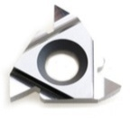  147 |  | 16IR ISO100 | K10-1 | Carbide | Uncoated | Aluminum alloy
148 |  | 16IR ISO125 | K10-1 | Carbide | Uncoated | Aluminum alloy
149 |  | 16IR ISO150 | K10-1 | Carbide | Uncoated | Aluminum alloy
150 |  | 16IR ISO175 | K10-1 | Carbide | Uncoated | Aluminum alloy
151 |  | 16IR ISO200 | K10-1 | Carbide | Uncoated | Aluminum alloy
152 |  | 16IR ISO250 | K10-1 | Carbide | Uncoated | Aluminum alloy
153 |  | 16IR ISO300 | K10-1 | Carbide | Uncoated | Aluminum alloy
154 | 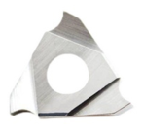 | TGF32R/L 100 | K10-1 | Carbide | Uncoated | Aluminum alloy
155 |  | TGF32R/L 105 | K10-1 | Carbide | Uncoated | Aluminum alloy
156 |  | TGF32R/L 110 | K10-1 | Carbide | Uncoated | Aluminum alloy
157 |  | TGF32R/L 115 | K10-1 | Carbide | Uncoated | Aluminum alloy
158 |  | TGF32R/L 120 | K10-1 | Carbide | Uncoated | Aluminum alloy
159 |  | TGF32R/L 125 | K10-1 | Carbide | Uncoated | Aluminum alloy
160 |  | TGF32R/L 130 | K10-1 | Carbide | Uncoated | Aluminum alloy
161 |  | TGF32R/L 135 | K10-1 | Carbide | Uncoated | Aluminum alloy
162 |  | TGF32R/L 140 | K10-1 | Carbide | Uncoated | Aluminum alloy
163 |  | TGF32R/L 145 | K10-1 | Carbide | Uncoated | Aluminum alloy
164 |  | TGF32R/L 150 | K10-1 | Carbide | Uncoated | Aluminum alloy
165 |  | TGF32R/L 155 | K10-1 | Carbide | Uncoated | Aluminum alloy
166 |  | TGF32R/L 160 | K10-1 | Carbide | Uncoated | Aluminum alloy
167 |  | TGF32R/L 165 | K10-1 | Carbide | Uncoated | Aluminum alloy
168 |  | TGF32R/L 170 | K10-1 | Carbide | Uncoated | Aluminum alloy
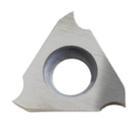  169 |  | TGF32R/L 175 | K10-1 | Carbide | Uncoated | Aluminum alloy
170 |  | TGF32R/L 180 | K10-1 | Carbide | Uncoated | Aluminum alloy
171 |  | TGF32R/L 185 | K10-1 | Carbide | Uncoated | Aluminum alloy
172 |  | TGF32R/L 190 | K10-1 | Carbide | Uncoated | Aluminum alloy
173 |  | TGF32R/L 195 | K10-1 | Carbide | Uncoated | Aluminum alloy
174 |  | TGF32R/L 200 | K10-1 | Carbide | Uncoated | Aluminum alloy
175 |  | TGF32R/L 205 | K10-1 | Carbide | Uncoated | Aluminum alloy
176 |  | TGF32R/L 210 | K10-1 | Carbide | Uncoated | Aluminum alloy
177 |  | TGF32R/L 215 | K10-1 | Carbide | Uncoated | Aluminum alloy
178 |  | TGF32R/L 220 | K10-1 | Carbide | Uncoated | Aluminum alloy
179 |  | TGF32R/L 225 | K10-1 | Carbide | Uncoated | Aluminum alloy
180 |  | TGF32R/L 230 | K10-1 | Carbide | Uncoated | Aluminum alloy
181 |  | TGF32R/L 235 | K10-1 | Carbide | Uncoated | Aluminum alloy
182 |  | TGF32R/L 240 | K10-1 | Carbide | Uncoated | Aluminum alloy
183 |  | TGF32R/L 245 | K10-1 | Carbide | Uncoated | Aluminum alloy
184 |  | TGF32R/L 250 | K10-1 | Carbide | Uncoated | Aluminum alloy
185 |  | TGF32R/L 255 | K10-1 | Carbide | Uncoated | Aluminum alloy
186 |  | TGF32R/L 260 | K10-1 | Carbide | Uncoated | Aluminum alloy
187 |  | TGF32R/L 265 | K10-1 | Carbide | Uncoated | Aluminum alloy
188 |  | TGF32R/L 270 | K10-1 | Carbide | Uncoated | Aluminum alloy
189 |  | TGF32R/L 275 | K10-1 | Carbide | Uncoated | Aluminum alloy
190 |  | TGF32R/L 280 | K10-1 | Carbide | Uncoated | Aluminum alloy
191 |  | TGF32R/L 285 | K10-1 | Carbide | Uncoated | Aluminum alloy
192 |  | TGF32R/L 290 | K10-1 | Carbide | Uncoated | Aluminum alloy
193 |  | TGF32R/L 295 | K10-1 | Carbide | Uncoated | Aluminum alloy
194 |  | TGF32R/L 300 | K10-1 | Carbide | Uncoated | Aluminum alloy
Grade：K10-1
With fine grain carbide matrix and sharp tool edge, excellent wear resistance, it is suitable for aluminum alloy and other non-ferrous metal semi-finishing to high-speed finishing.

