Carbide Turning Inserts for Steel
The following is the standard stock turning tool of our company, which is suitable for roughing, finishing and semi-finishing steel parts.
Carbide Inserts-JC Series
No. | Reference  Photo | Type |  |  | Grade | Material |  | Coating |  | Work-piece Materials
1 | 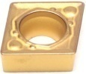 | CCMT060202-Q1 |  |  | TBC2005 | Carbide |  | CVD |  | Steel
2 |  | CCMT060204-Q1 |  |  | TBC2005 | Carbide |  | CVD |  | Steel
3 |  | CCMT09T302-Q1 |  |  | TBC2005 | Carbide |  | CVD |  | Steel
4 |  | CCMT09T304-Q1 |  |  | TBC2005 | Carbide |  | CVD |  | Steel
5 |  | CCMT09T308-Q1 |  |  | TBC2005 | Carbide |  | CVD |  | Steel
6 | 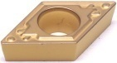 | DCMT070202-Q1 |  |  | TBC2005 | Carbide |  | CVD |  | Steel
7 |  | DCMT070204-Q1 |  |  | TBC2005 | Carbide |  | CVD |  | Steel
8 |  | DCMT070208-Q1 |  |  | TBC2005 | Carbide |  | CVD |  | Steel
9 |  | DCMT11T302-Q1 |  |  | TBC2005 | Carbide |  | CVD |  | Steel
10 |  | DCMT11T304-Q1 |  |  | TBC2005 | Carbide |  | CVD |  | Steel
11 |  | DCMT11T308-Q1 |  |  | TBC2005 | Carbide |  | CVD |  | Steel
12 | 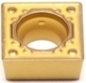 | SCMT09T304-Q1 |  |  | TBC2005 | Carbide |  | CVD |  | Steel
13 |  | SCMT09T308-Q1 |  |  | TBC2005 | Carbide |  | CVD |  | Steel
14 | 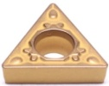 | TCMT090204-Q1 |  |  | TBC2005 | Carbide |  | CVD |  | Steel
15 |  | TCMT090208-Q1 |  |  | TBC2005 | Carbide |  | CVD |  | Steel
16 |  | TCMT110202-Q1 |  |  | TBC2005 | Carbide |  | CVD |  | Steel
17 |  | TCMT110204-Q1 |  |  | TBC2005 | Carbide |  | CVD |  | Steel
18 |  | TCMT110208-Q1 |  |  | TBC2005 | Carbide |  | CVD |  | Steel
19 | 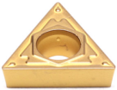 | TCMT16T304-Q1 |  |  | TBC2005 | Carbide |  | CVD |  | Steel
20 |  | TCMT16T308-Q1 |  |  | TBC2005 | Carbide |  | CVD |  | Steel
21 | 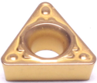 | TPMT090204-Q1 |  |  | TBC2005 | Carbide |  | CVD |  | Steel
22 |  | TPMT110304-Q1 |  |  | TBC2005 | Carbide |  | CVD |  | Steel
23 |  | TPMT110308-Q1 |  |  | TBC2005 | Carbide |  | CVD |  | Steel
24 | 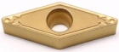 | VBMT110304-Q1 |  |  | TBC2005 | Carbide |  | CVD |  | Steel
25 |  | VBMT110308-Q1 |  |  | TBC2005 | Carbide |  | CVD |  | Steel
26 |  | VBMT160404-Q1 |  |  | TBC2005 | Carbide |  | CVD |  | Steel
27 |  | VBMT160408-Q1 |  |  | TBC2005 | Carbide |  | CVD |  | Steel
28 | 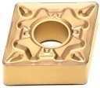 | CNMG120404-Q1 |  |  | TBC2005 | Carbide |  | CVD |  | Steel
29 |  | CNMG120408-Q1 |  |  | TBC2005 | Carbide |  | CVD |  | Steel
30 |  | CNMG120412-Q1 |  |  | TBC2005 | Carbide |  | CVD |  | Steel
31 | 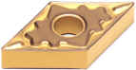 | DNMG150404-Q1 |  |  | TBC2005 | Carbide |  | CVD |  | Steel
32 |  | DNMG150408-Q1 |  |  | TBC2005 | Carbide |  | CVD |  | Steel
33 |  | DNMG150608-Q1 |  |  | TBC2005 | Carbide |  | CVD |  | Steel
34 | 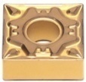 | SNMG120404-Q1 |  |  | TBC2005 | Carbide |  | CVD |  | Steel
35 |  | SNMG120408-Q1 |  |  | TBC2005 | Carbide |  | CVD |  | Steel
36 | 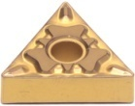 | TNMG160404-Q1 |  |  | TBC2005 | Carbide |  | CVD |  | Steel
37 |  | TNMG160408-Q1 |  |  | TBC2005 | Carbide |  | CVD |  | Steel
38 |  | TNMG160412-Q1 |  |  | TBC2005 | Carbide |  | CVD |  | Steel
39 | 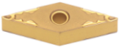 | VNMG160404-Q1 |  |  | TBC2005 | Carbide |  | CVD |  | Steel
40 |  | VNMG160408-Q1 |  |  | TBC2005 | Carbide |  | CVD |  | Steel
41 | 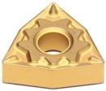 | WNMG080404-Q1 |  |  | TBC2005 | Carbide |  | CVD |  | Steel
42 |  | WNMG080408-Q1 |  |  | TBC2005 | Carbide |  | CVD |  | Steel
43 |  | WNMG080412-Q1 |  |  | TBC2005 | Carbide |  | CVD |  | Steel
Carbide Inserts-DZ Series
No. | Reference  Photo | Type | Grade | Material | Coating | Work-piece  Materials
1 |  | CNMG120404-MM | TBC2005 | Carbide | CVD | Steel
2 |  | CNMG120408-MM | TBC2005 | Carbide | CVD | Steel
3 |  | CNMG120412-MM | TBC2005 | Carbide | CVD | Steel
4 |  | DNMG150404-MM | TBC2005 | Carbide | CVD | Steel
5 |  | DNMG150408-MM | TBC2005 | Carbide | CVD | Steel
6 |  | SNMG120404-MM | TBC2005 | Carbide | CVD | Steel
7 |  | SNMG120408-MM | TBC2005 | Carbide | CVD | Steel
8 |  | TNMG160404-MM | TBC2005 | Carbide | CVD | Steel
9 |  | TNMG160408-MM | TBC2005 | Carbide | CVD | Steel
10 |  | TNMG160412-MM | TBC2005 | Carbide | CVD | Steel
11 |  | VNMG160404-MM | TBC2005 | Carbide | CVD | Steel
12 |  | VNMG160408-MM | TBC2005 | Carbide | CVD | Steel
13 |  | WNMG080404-MM | TBC2005 | Carbide | CVD | Steel
14 |  | WNMG080408-MM | TBC2005 | Carbide | CVD | Steel
15 |  | WNMG080412-MM | TBC2005 | Carbide | CVD | Steel
16 |  | TNMG160404R-S | TBC2005 | Carbide | CVD | Steel
17 |  | TNMG160404L-S | TBC2005 | Carbide | CVD | Steel
18 |  | TNMG160408R-S | TBC2005 | Carbide | CVD | Steel
19 |  | TNMG160408L-S | TBC2005 | Carbide | CVD | Steel
20 |  | WNMG080404R-S | TBC2005 | Carbide | CVD | Steel
21 |  | WNMG080404L-S | TBC2005 | Carbide | CVD | Steel
22 |  | WNMG080408R-S | TBC2005 | Carbide | CVD | Steel
23 |  | WNMG080408L-S | TBC2005 | Carbide | CVD | Steel
24 |  | SNMG120404R-S | TBC2005 | Carbide | CVD | Steel
25 |  | SNMG120404L-S | TBC2005 | Carbide | CVD | Steel
26 |  | SNMG120408R-S | TBC2005 | Carbide | CVD | Steel
27 |  | SNMG120408L-S | TBC2005 | Carbide | CVD | Steel
Grade: TBC2005
CVD(MT-TiCN+Al₂O₃+TiN)
The combination of high strength and high toughness substrate plus MT-TiCN, thick Al₂O₃ and TiN coating is suitable for semi-finishing of steel parts.
Carbide Inserts-ST Series
No. | Reference Photo |  | Grade | Type |  |  | Material |  | Coating |  | Work-piece Materials
1 | 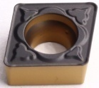 |  | TBC2015 | CCMT09T308-PM |  |  | Carbide |  | CVD |  | Steel
2 |  |  | TBC2015 | CCMT09T308-PM |  |  | Carbide |  | CVD |  | Steel
3 | 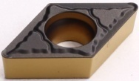 |  | TBC2015 | DCMT11T304-PM |  |  | Carbide |  | CVD |  | Steel
4 |  |  | TBC2015 | DCMT11T308-PM |  |  | Carbide |  | CVD |  | Steel
5 | 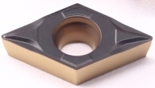 |  | TBC2015 | DCMT11T304-PF |  |  | Carbide |  | CVD |  | Steel
6 | 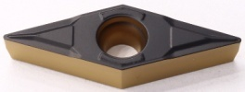 |  | TBC2015 | VBMT160404-PF |  |  | Carbide |  | CVD |  | Steel
7 | 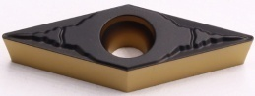 |  | TBC2015 | VBMT160404-PM |  |  | Carbide |  | CVD |  | Steel
8 |  |  | TBC2015 | VBMT160408-PM |  |  | Carbide |  | CVD |  | Steel
9 | 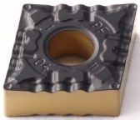 |  | TBC2015 | CNMG120404-PF |  |  | Carbide |  | CVD |  | Steel
10 |  |  | TBC2015 | CNMG120408-PF |  |  | Carbide |  | CVD |  | Steel
11 | 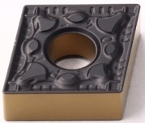 |  | TBC2015 | CNMG120404-PM |  |  | Carbide |  | CVD |  | Steel
12 |  |  | TBC2015 | CNMG120408-PM |  |  | Carbide |  | CVD |  | Steel
13 | 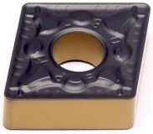 |  | TBC2015 | CNMG160608-PM |  |  | Carbide |  | CVD |  | Steel
14 |  |  | TBC2015 | CNMG160612-PM |  |  | Carbide |  | CVD |  | Steel
15 |  |  | TBC2015 | CNMG190608-PM |  |  | Carbide |  | CVD |  | Steel
16 | 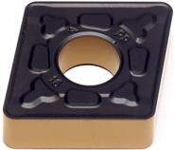 |  | TBC2015 | CNMG190612-PR |  |  | Carbide |  | CVD |  | Steel
17 |  |  | TBC2015 | CNMG190616-PR |  |  | Carbide |  | CVD |  | Steel
18 |  |  | TBC2015 | CNMG250924-PR |  |  | Carbide |  | CVD |  | Steel
19 |  |  | TBC2015 | CNMM250924-PR |  |  | Carbide |  | CVD |  | Steel
20 | 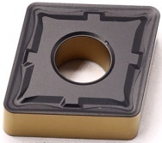 |  | TBC2015 | CNMG190616-M5 |  |  | Carbide |  | CVD |  | Steel
21 | 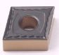 |  | TBC2015 | CNMG160604-QM |  |  | Carbide |  | CVD |  | Steel
22 | 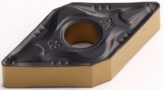 |  | TBC2015 | DNMG150404-PM |  |  | Carbide |  | CVD |  | Steel
23 |  |  | TBC2015 | DNMG150408-PM |  |  | Carbide |  | CVD |  | Steel
24 |  |  | TBC2015 | DNMG150604-PM |  |  | Carbide |  | CVD |  | Steel
25 |  |  | TBC2015 | DNMG150608-PM |  |  | Carbide |  | CVD |  | Steel
26 |  |  | TBC2015 | DNMG150612-PM |  |  | Carbide |  | CVD |  | Steel
27 | 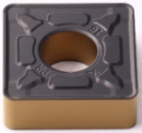 |  | TBC2015 | SNMG190612-PR |  |  | Carbide |  | CVD |  | Steel
28 |  |  | TBC2015 | SNMG190616-PR |  |  | Carbide |  | CVD |  | Steel
29 |  |  | TBC2015 | SNMM190612-PR |  |  | Carbide |  | CVD |  | Steel
30 | 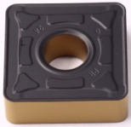 |  | TBC2015 | SNMG250724-PR |  |  | Carbide |  | CVD |  | Steel
31 |  |  | TBC2015 | SNMG250924-PR |  |  | Carbide |  | CVD |  | Steel
32 | 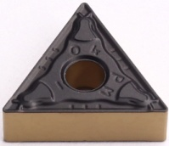 |  | TBC2015 | TNMG160404-PM |  |  | Carbide |  | CVD |  | Steel
33 |  |  | TBC2015 | TNMG160408-PM |  |  | Carbide |  | CVD |  | Steel
34 |  |  | TBC2016 | TNMG220404-PM |  |  | Carbide |  | CVD |  | Steel
35 |  |  | TBC2015 | TNMG220408-PM |  |  | Carbide |  | CVD |  | Steel
36 | 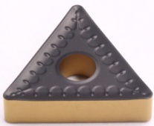 |  | TBC2015 | TNMM270612-PR |  |  | Carbide |  | CVD |  | Steel
37 | 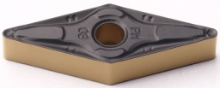 |  | TBC2015 | VNMG160408-PM |  |  | Carbide |  | CVD |  | Steel
38 | 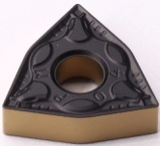 |  | TBC2015 | WNMG080404-PM |  |  | Carbide |  | CVD |  | Steel
39 |  |  | TBC2015 | WNMG080408-PM |  |  | Carbide |  | CVD |  | Steel
Grade TBC2005 is a combination of high strength and high toughness substrate plus MT-TiCN, thick Al₂O₃ and TiN coating is suitable for semi-finishing of steel parts.
Grade TBC2015 is a combination of high wear resistance substrate and CVD coating has strong plastic deformation resistance and edge strength. It is suitable for finishing to semi-finish machining for steel and it is easy to recognize wear.

