- Cermet Turning Inserts
Standard stock:
Turning-SL，Turning-TGK，Turning-JC，Turning-DZ
Cermet is uncoated and used for processing steel parts.
Cermet Inserts-SL Series
No. |  |  | Reference  Photo |  |  | Type |  | Grade |  |  |  | Material | Coating |  | Work-piece  Materials
1 |  |  | 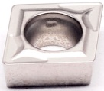 |  |  | CCMT060202-TF |  | T45A |  |  |  | Cermet | Uncoated |  | Steel
2 |  |  |  |  |  | CCMT060204-TF |  | T45A |  |  |  | Cermet | Uncoated |  | Steel
3 |  |  |  |  |  | CCMT060208-TF |  | T45A |  |  |  | Cermet | Uncoated |  | Steel
4 |  |  |  |  |  | CCMT09T302-TF |  | T45A |  |  |  | Cermet | Uncoated |  | Steel
5 |  |  |  |  |  | CCMT09T304-TF |  | T45A |  |  |  | Cermet | Uncoated |  | Steel
6 |  |  |  |  |  | CCMT09T308-TF |  | T45A |  |  |  | Cermet | Uncoated |  | Steel
7 |  |  |  |  |  | CCMT120404-TF |  | T45A |  |  |  | Cermet | Uncoated |  | Steel
8 |  |  |  |  |  | CCMT120408-TF |  | T45A |  |  |  | Cermet | Uncoated |  | Steel
9 |  |  | 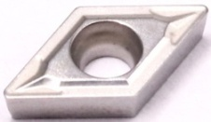 |  |  | DCMT070202-TF |  | T45A |  |  |  | Cermet | Uncoated |  | Steel
10 |  |  |  |  |  | DCMT070204-TF |  | T45A |  |  |  | Cermet | Uncoated |  | Steel
11 |  |  |  |  |  | DCMT11T304-TF |  | T45A |  |  |  | Cermet | Uncoated |  | Steel
12 |  |  | 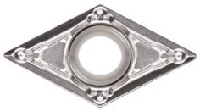 |  |  | DCMT11T304-MV |  | T45A |  |  |  | Cermet | Uncoated |  | Steel
13 |  |  |  |  |  | DCMT11T308-MV |  | T45A |  |  |  | Cermet | Uncoated |  | Steel
14 |  |  | 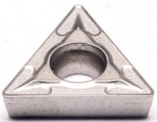 |  |  | TCMT110202-TF |  | T45A |  |  |  | Cermet | Uncoated |  | Steel
15 |  |  |  |  |  | TCMT110204-TF |  | T45A |  |  |  | Cermet | Uncoated |  | Steel
16 |  |  |  |  |  | TCMT110208-TF |  | T45A |  |  |  | Cermet | Uncoated |  | Steel
17 |  |  |  |  |  | TCMT16T304-TF |  | T45A |  |  |  | Cermet | Uncoated |  | Steel
18 |  |  |  |  |  | TCMT16T308-TF |  | T45A |  |  |  | Cermet | Uncoated |  | Steel
19 |  |  | 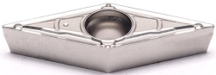 |  |  | VBMT110304-MV |  | T45A |  |  |  | Cermet | Uncoated |  | Steel
20 |  |  |  |  |  | VBMT160404-MV |  | T45A |  |  |  | Cermet | Uncoated |  | Steel
21 |  |  |  |  |  | VBMT160408-MV |  | T45A |  |  |  | Cermet | Uncoated |  | Steel
22 |  |  | 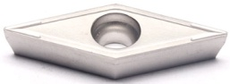 |  |  | VCMT110304-GV |  | T45A |  |  |  | Cermet | Uncoated |  | Steel
23 |  |  |  |  |  | VCMT160404-GV |  | T45A |  |  |  | Cermet | Uncoated |  | Steel
24 |  |  | 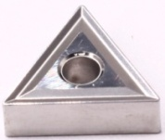 |  |  | TNMG160404-TV |  | T45A |  |  |  | Cermet | Uncoated |  | Steel
25 |  |  |  |  |  | TNMG160408-TV |  | T45A |  |  |  | Cermet | Uncoated |  | Steel
26 |  |  | 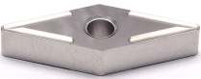 |  |  | VNMG160404-GV |  | T45A |  |  |  | Cermet | Uncoated |  | Steel
27 |  |  |  |  |  | VNMG160408-GV |  | T45A |  |  |  | Cermet | Uncoated |  | Steel
28 |  |  | 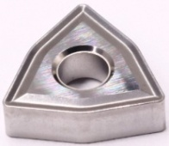 |  |  | WNMG080404-TV |  | T45A |  |  |  | Cermet | Uncoated |  | Steel
29 |  |  |  |  |  | WNMG080408-TV |  | T45A |  |  |  | Cermet | Uncoated |  | Steel
 | Cermet Inserts-JC Series
 | No. |  | Reference  Photo |  | Type |  |  |  | Grade |  | Material |  | Coating |  | Work-piece  Materials
 | 1 |  | 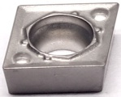 |  | CCMT060202-Q1 |  |  |  | T45A |  | Cermet |  | Uncoated |  | Steel
 | 2 |  |  |  | CCMT060204-Q1 |  |  |  | T45A |  | Cermet |  | Uncoated |  | Steel
 | 3 |  | 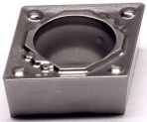 |  | CCMT09T302-Q1 |  |  |  | T45A |  | Cermet |  | Uncoated |  | Steel
 | 4 |  |  |  | CCMT09T304-Q1 |  |  |  | T45A |  | Cermet |  | Uncoated |  | Steel
 | 5 |  |  |  | CCMT09T308-Q1 |  |  |  | T45A |  | Cermet |  | Uncoated |  | Steel
 | 9 |  | 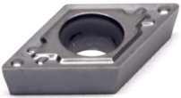 |  | DCMT070202-Q1 |  |  |  | T45A |  | Cermet |  | Uncoated |  | Steel
 | 10 |  |  |  | DCMT070204-Q1 |  |  |  | T45A |  | Cermet |  | Uncoated |  | Steel
 | 11 |  |  |  | DCMT070208-Q1 |  |  |  | T45A |  | Cermet |  | Uncoated |  | Steel
 | 12 |  |  |  | DCMT11T302-Q1 |  |  |  | T45A |  | Cermet |  | Uncoated |  | Steel
 | 13 |  |  |  | DCMT11T304-Q1 |  |  |  | T45A |  | Cermet |  | Uncoated |  | Steel
 | 14 |  |  |  | DCMT11T308-Q1 |  |  |  | T45A |  | Cermet |  | Uncoated |  | Steel
 | 19 |  | 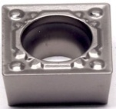 |  | SCMT09T304-Q1 |  |  |  | T45A |  | Cermet |  | Uncoated |  | Steel
 | 20 |  |  |  | SCMT09T308-Q1 |  |  |  | T45A |  | Cermet |  | Uncoated |  | Steel
 | 23 |  | 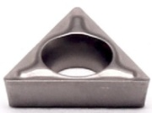 |  | TBMT060102-DP |  |  |  | T45A |  | Cermet |  | Uncoated |  | Steel
 | 24 |  |  |  | TBMT060104-DP |  |  |  | T45A |  | Cermet |  | Uncoated |  | Steel
 | 25 |  | 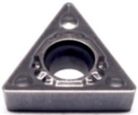 |  | TCMT090204-Q1 |  |  |  | T45A |  | Cermet |  | Uncoated |  | Steel
 | 26 |  |  |  | TCMT090208-Q1 |  |  |  | T45A |  | Cermet |  | Uncoated |  | Steel
 | 27 |  | 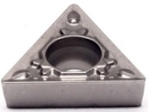 |  | TCMT110202-Q1 |  |  |  | T45A |  | Cermet |  | Uncoated |  | Steel
 | 28 |  |  |  | TCMT110204-Q1 |  |  |  | T45A |  | Cermet |  | Uncoated |  | Steel
 | 29 |  |  |  | TCMT110208-Q1 |  |  |  | T45A |  | Cermet |  | Uncoated |  | Steel
 | 30 |  | 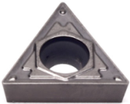 |  | TCMT16T304-Q1 |  |  |  | T45A |  | Cermet |  | Uncoated |  | Steel
 | 31 |  |  |  | TCMT16T308-Q1 |  |  |  | T45A |  | Cermet |  | Uncoated |  | Steel
 | 35 |  | 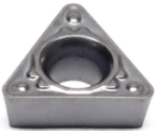 |  | TPMT090204-Q1 |  |  |  | T45A |  | Cermet |  | Uncoated |  | Steel
 | 36 |  |  |  | TPMT110304-Q1 |  |  |  | T45A |  | Cermet |  | Uncoated |  | Steel
 | 37 |  |  |  | TPMT110308-Q1 |  |  |  | T45A |  | Cermet |  | Uncoated |  | Steel
 | 38 |  | 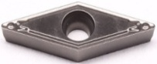 |  | VBMT110304-Q1 |  |  |  | T45A |  | Cermet |  | Uncoated |  | Steel
 | 39 |  |  |  | VBMT110308-Q1 |  |  |  | T45A |  | Cermet |  | Uncoated |  | Steel
 | 40 |  |  |  | VBMT160404-Q1 |  |  |  | T45A |  | Cermet |  | Uncoated |  | Steel
 | 41 |  |  |  | VBMT160408-Q1 |  |  |  | T45A |  | Cermet |  | Uncoated |  | Steel
 | 42 |  | 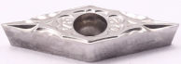 |  | VBMT110302-VF |  |  |  | T45A |  | Cermet |  | Uncoated |  | Steel
 | 43 |  |  |  | VBMT110304-VF |  |  |  | T45A |  | Cermet |  | Uncoated |  | Steel
 | 44 |  |  |  | VBMT160402-VF |  |  |  | T45A |  | Cermet |  | Uncoated |  | Steel
 | 45 |  |  |  | VBMT160404-VF |  |  |  | T45A |  | Cermet |  | Uncoated |  | Steel
 | 46 |  | 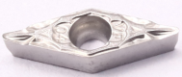 |  | VCMT080202-VF |  |  |  | T45A |  | Cermet |  | Uncoated |  | Steel
 | 47 |  |  |  | VCMT080204-VF |  |  |  | T45A |  | Cermet |  | Uncoated |  | Steel
 | 48 |  | 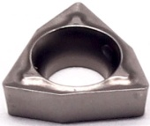 |  | WBMT060102L-DP |  |  |  | T45A |  | Cermet |  | Uncoated |  | Steel
 | 49 |  |  |  | WBMT060104L-DP |  |  |  | T45A |  | Cermet |  | Uncoated |  | Steel
 | 50 |  | 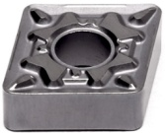 |  | CNMG120404-Q1 |  |  |  | T45A |  | Cermet |  | Uncoated |  | Steel
 | 51 |  |  |  | CNMG120408-Q1 |  |  |  | T45A |  | Cermet |  | Uncoated |  | Steel
 | 52 |  |  |  | CNMG120412-Q1 |  |  |  | T45A |  | Cermet |  | Uncoated |  | Steel
 | 53 |  |  |  | DNMG150404-Q1 |  |  |  | T45A |  | Cermet |  | Uncoated |  | Steel
 | 54 |  | 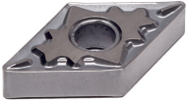 |  | DNMG150408-Q1 |  |  |  | T45A |  | Cermet |  | Uncoated |  | Steel
 | 55 |  |  |  | DNMG150604-Q1 |  |  |  | T45A |  | Cermet |  | Uncoated |  | Steel
 | 56 |  |  |  | DNMG150608-Q1 |  |  |  | T45A |  | Cermet |  | Uncoated |  | Steel
 | 57 |  | 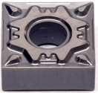 |  | SNMG120404-Q1 |  |  |  | T45A |  | Cermet |  | Uncoated |  | Steel
 | 58 |  |  |  | SNMG120408-Q1 |  |  |  | T45A |  | Cermet |  | Uncoated |  | Steel
 | 59 |  | 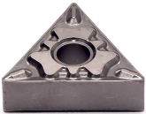 |  | TNMG160404-Q1 |  |  |  | T45A |  | Cermet |  | Uncoated |  | Steel
 | 60 |  |  |  | TNMG160408-Q1 |  |  |  | T45A |  | Cermet |  | Uncoated |  | Steel
 | 61 |  |  |  | TNMG160412-Q1 |  |  |  | T45A |  | Cermet |  | Uncoated |  | Steel
 | 62 |  | 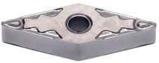 |  | VNMG160404-Q1 |  |  |  | T45A |  | Cermet |  | Uncoated |  | Steel
 | 63 |  |  |  | VNMG160408-Q1 |  |  |  | T45A |  | Cermet |  | Uncoated |  | Steel
 | 64 |  | 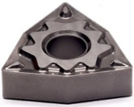 |  | WNMG080404-Q1 |  |  |  | T45A |  | Cermet |  | Uncoated |  | Steel
 | 65 |  |  |  | WNMG080408-Q1 |  |  |  | T45A |  | Cermet |  | Uncoated |  | Steel
 | 66 |  |  |  | WNMG080412-Q1 |  |  |  | T45A |  | Cermet |  | Uncoated |  | Steel
 |  | Cermet Inserts-DZ Series
 |  | No. |  | Reference  Photo |  |  | Type |  |  | Grade |  | Material | Coating | Work-piece  Materials
 |  | 1 |  | 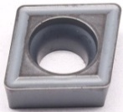 |  |  | CCMT060202-24 |  |  | T45A |  | Cermet | Uncoated | Steel
 |  | 2 |  |  |  |  | CCMT060204-24 |  |  | T45A |  | Cermet | Uncoated | Steel
 |  | 3 |  |  |  |  | CCMT060208-24 |  |  | T45A |  | Cermet | Uncoated | Steel
 |  | 4 |  |  |  |  | CCMT09T302-24 |  |  | T45A |  | Cermet | Uncoated | Steel
 |  | 5 |  |  |  |  | CCMT09T304-24 |  |  | T45A |  | Cermet | Uncoated | Steel
 |  | 6 |  |  |  |  | CCMT09T308-24 |  |  | T45A |  | Cermet | Uncoated | Steel
 |  | 7 |  | 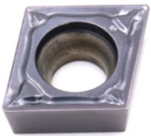 |  |  | CCMT060202-PS |  |  | T45A |  | Cermet | Uncoated | Steel
 |  | 8 |  |  |  |  | CCMT060204-PS |  |  | T45A |  | Cermet | Uncoated | Steel
 |  | 9 |  |  |  |  | CCMT060208-PS |  |  | T45A |  | Cermet | Uncoated | Steel
 |  | 10 |  |  |  |  | CCMT09T302-PS |  |  | T45A |  | Cermet | Uncoated | Steel
 |  | 11 |  |  |  |  | CCMT09T304-PS |  |  | T45A |  | Cermet | Uncoated | Steel
 |  | 12 |  |  |  |  | CCMT09T308-PS |  |  | T45A |  | Cermet | Uncoated | Steel
 |  | 13 |  | 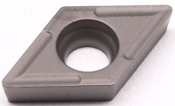 |  |  | DCMT070204-24 |  |  | T45A |  | Cermet | Uncoated | Steel
 |  | 14 |  | 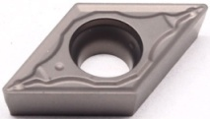 |  |  | DCMT070204-PS |  |  | T45A |  | Cermet | Uncoated | Steel
 |  | 15 |  |  |  |  | DCMT070208-PS |  |  | T45A |  | Cermet | Uncoated | Steel
 |  | 16 |  |  |  |  | DCMT11T302-PS |  |  | T45A |  | Cermet | Uncoated | Steel
 |  | 17 |  |  |  |  | DCMT11T304-PS |  |  | T45A |  | Cermet | Uncoated | Steel
 |  | 18 |  |  |  |  | DCMT11T308-PS |  |  | T45A |  | Cermet | Uncoated | Steel
 |  | 19 |  | 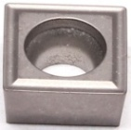 |  |  | SCMT09T304-24 |  |  | T45A |  | Cermet | Uncoated | Steel
 |  | 20 |  | 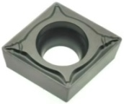 |  |  | SCMT090308-PS |  |  | T45A |  | Cermet | Uncoated | Steel
 |  | 21 |  |  |  |  | SCMT09T304-PS |  |  | T45A |  | Cermet | Uncoated | Steel
 |  | 22 |  | 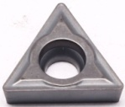 |  |  | TCMT090204-24 |  |  | T45A |  | Cermet | Uncoated | Steel
 |  | 23 |  |  |  |  | TCMT110204-24 |  |  | T45A |  | Cermet | Uncoated | Steel
 |  | 24 |  |  |  |  | TCMT110202-24 |  |  | T45A |  | Cermet | Uncoated | Steel
 |  | 25 |  | 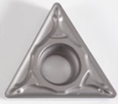 |  |  | TCMT110202-PS |  |  | T45A |  | Cermet | Uncoated | Steel
 |  | 26 |  |  |  |  | TCMT110204-PS |  |  | T45A |  | Cermet | Uncoated | Steel
 |  | 27 |  |  |  |  | TCMT110208-PS |  |  | T45A |  | Cermet | Uncoated | Steel
 |  | 28 |  | 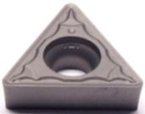 |  |  | TCMT16T304-PS |  |  | T45A |  | Cermet | Uncoated | Steel
 |  | 29 |  |  |  |  | TCMT16T308-PS |  |  | T45A |  | Cermet | Uncoated | Steel
 |  | 30 |  | 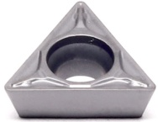 |  |  | TPMT090204-PS |  |  | T45A |  | Cermet | Uncoated | Steel
 |  | 31 |  |  |  |  | TPMT110304-PS |  |  | T45A |  | Cermet | Uncoated | Steel
 |  | 32 |  |  |  |  | TPMT110308-PS |  |  | T45A |  | Cermet | Uncoated | Steel
 |  | 33 |  | 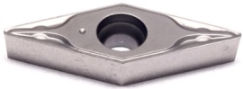 |  |  | XVBMT110302-PS |  |  | T45A |  | Cermet | Uncoated | Steel
 |  | 34 |  |  |  |  | XVBMT110304-PS |  |  | T45A |  | Cermet | Uncoated | Steel
 |  | 35 |  |  |  |  | XVCMT110302-PS |  |  | T45A |  | Cermet | Uncoated | Steel
 |  | 36 |  | 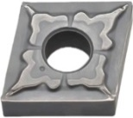 |  |  | CNMG120404-TS |  |  | T45A |  | Cermet | Uncoated | Steel
 |  | 37 |  |  |  |  | CNMG120408-TS |  |  | T45A |  | Cermet | Uncoated | Steel
 |  | 38 |  | 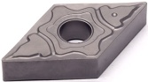 |  |  | DNMG150404-TS |  |  | T45A |  | Cermet | Uncoated | Steel
 |  | 39 |  | 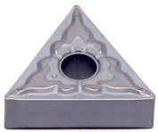 |  |  | TNMG160404-TS |  |  | T45A |  | Cermet | Uncoated | Steel
 |  | 40 |  |  |  |  | TNMG160408-TS |  |  | T45A |  | Cermet | Uncoated | Steel
 |  | 41 |  | 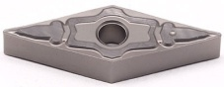 |  |  | VNMG160404-TS |  |  | T45A |  | Cermet | Uncoated | Steel
 |  | 42 |  |  |  |  | VNMG160408-TS |  |  | T45A |  | Cermet | Uncoated | Steel
 |  | 43 |  | 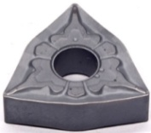 |  |  | WNMG080404-TS |  |  | T45A |  | Cermet | Uncoated | Steel
 |  | 44 |  |  |  |  | WNMG080408-TS |  |  | T45A |  | Cermet | Uncoated | Steel
 |  | 45 |  | 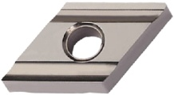 |  |  | DNMG150604R-S |  |  | T45A |  | Cermet | Uncoated | Steel
 |  | 46 |  |  |  |  | DNMG150608R-S |  |  | T45A |  | Cermet | Uncoated | Steel
 |  | 47 |  | 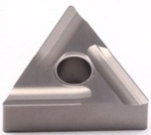 |  |  | TNMG160404L-S |  |  | T45A |  | Cermet | Uncoated | Steel
 |  | 48 |  |  |  |  | TNMG160404R-S |  |  | T45A |  | Cermet | Uncoated | Steel
 |  | 49 |  |  |  |  | TNMG160408L-S |  |  | T45A |  | Cermet | Uncoated | Steel
 |  | 50 |  |  |  |  | TNMG160408R-S |  |  | T45A |  | Cermet | Uncoated | Steel
 |  | 51 |  | 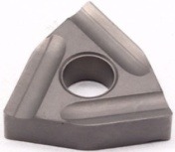 |  |  | WNMG080404L-S |  |  | T45A |  | Cermet | Uncoated | Steel
 |  | 52 |  |  |  |  | WNMG080404R-S |  |  | T45A |  | Cermet | Uncoated | Steel
 |  | 53 |  |  |  |  | WNMG080408L-S |  |  | T45A |  | Cermet | Uncoated | Steel
 |  | 54 |  |  |  |  | WNMG080408R-S |  |  | T45A |  | Cermet | Uncoated | Steel
Grade:
T45A (TiCN) based cermet material, with strong crater wear resistance and can withstand certain impact loads, suitable for semi-finish of low-carbon steel, low-alloy steel, gray cast iron, silicon-aluminum alloy and stainless steel.
Application: cermet tool is suitable for processing all kinds of steel and cast iron parts of semi-finishing and finishing, when the cutting depth is below 2.5mm, the feed rate per revolution is below 0.25mm/r, the feed rate per tooth is below 0.2mm/tooth, cermet tool has excellent cutting performance.

