Carbide Turning Inserts for High Temperature Alloy
Standing standard stock
Carbide Inserts-KN Series
No. | Reference Photo | Type | Grade | Material | Coating | Work-piece Materials
1 | 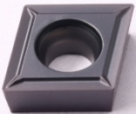 | CCMT060202-67 | MS1030 | Carbide | PVD | Steel, heat treatment materials, high temperature alloy
2 |  | CCMT060204-67 | MS1030 | Carbide | PVD
3 |  | CCMT060208-67 | MS1030 | Carbide | PVD
4 |  | CCMT09T302-67 | MS1030 | Carbide | PVD
5 |  | CCMT09T304-67 | MS1030 | Carbide | PVD
6 |  | CCMT09T308-67 | MS1030 | Carbide | PVD
7 |  | CCMT120404-67 | MS1030 | Carbide | PVD
8 |  | CCMT120408-67 | MS1030 | Carbide | PVD
9 | 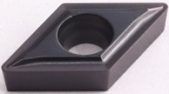 | DCMT070202-67 | MS1030 | Carbide | PVD
10 |  | DCMT070204-67 | MS1030 | Carbide | PVD
11 |  | DCMT11T302-67 | MS1030 | Carbide | PVD
12 |  | DCMT11T304-67 | MS1030 | Carbide | PVD
13 |  | DCMT11T308-67 | MS1030 | Carbide | PVD
14 | 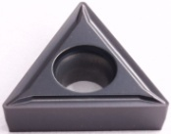 | TCMT110202-67 | MS1030 | Carbide | PVD
15 |  | TCMT110204-67 | MS1030 | Carbide | PVD
16 |  | TCMT16T304-67 | MS1030 | Carbide | PVD
17 |  | TCMT16T308-67 | MS1030 | Carbide | PVD
18 |  | TPMT090202-67 | MS1030 | Carbide | PVD
19 |  | TPMT090204-67 | MS1030 | Carbide | PVD
20 | 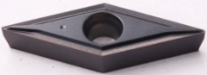 | VBMT110302-67 | MS1030 | Carbide | PVD
21 |  | VBMT110304-67 | MS1030 | Carbide | PVD
22 | 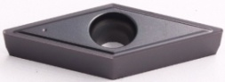 | VBMT160402-67 | MS1030 | Carbide | PVD
23 |  | VBMT160404-67 | MS1030 | Carbide | PVD
24 |  | VBMT160408-67 | MS1030 | Carbide | PVD
25 | 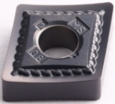 | CNMG120402-67 | MS1030 | Carbide | PVD
26 |  | CNMG120404-67 | MS1030 | Carbide | PVD
27 |  | CNMG120408-67 | MS1030 | Carbide | PVD
28 | 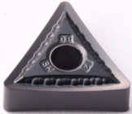 | TNMG160402-67 | MS1030 | Carbide | PVD
29 |  | TNMG160404-67 | MS1030 | Carbide | PVD
30 |  | TNMG160408-67 | MS1030 | Carbide | PVD
31 | 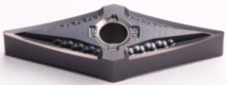 | VNMG160402-67 | MS1030 | Carbide | PVD
32 |  | VNMG160404-67 | MS1030 | Carbide | PVD

33 |  | 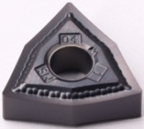 |  | WNMG080402-67 |  | MS1030 | Carbide |  | PVD
34 |  |  |  | WNMG080404-67 |  | MS1030 | Carbide |  | PVD
35 |  |  |  | WNMG080408-67 |  | MS1030 | Carbide |  | PVD
36 |  | 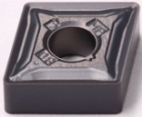 |  | CNMG120404-65 |  | MS1030 | Carbide |  | PVD
37 |  |  |  | CNMG120408-65 |  | MS1030 | Carbide |  | PVD
38 |  | 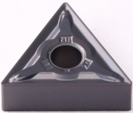 |  | TNMG160404-65 |  | MS1030 | Carbide |  | PVD
39 |  |  |  | TNMG160408-65 |  | MS1030 | Carbide |  | PVD
40 |  | 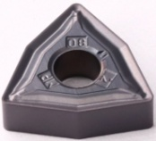 |  | WNMG080408-65 |  | MS1030 | Carbide |  | PVD
ZY-N Series CNC Inserts
No. | Reference  Photo |  | Type |  | Grade |  | Material | Coating |  | Work-piece  Materials
1 | 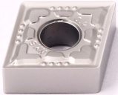 |  | CNMG120404-WT |  | MS1085 |  | Carbide | PVD |  | Stainless steel, high temperature alloy, titanium alloy
2 |  |  | CNMG120408-WT |  | MS1085 |  | Carbide | PVD
3 | 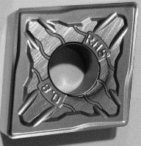 |  | CNMG160608-WT |  | MS1085 |  | Carbide | PVD
4 | 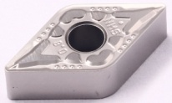 |  | DNMG150604-WT |  | MS1085 |  | Carbide | PVD
5 |  |  | DNMG150608-WT |  | MS1085 |  | Carbide | PVD
6 | 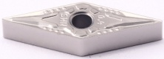 |  | VNMG160404-WT |  | MS1085 |  | Carbide | PVD
7 |  |  | VNMG160408-WT |  | MS1085 |  | Carbide | PVD
8 | 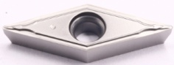 |  | VCMT160404-WT |  | MS1085 |  | Carbide | PVD
9 |  |  | VCMT160408-WT |  | MS1085 |  | Carbide | PVD
10 | 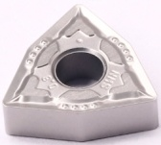 |  | WNMG080408-WT |  | MS1085 |  | Carbide | PVD
Grade MS1085: A PVD coating material with both wear and heat resistance, especially suitable for semi-finishing and finishing of stainless steel and high temperature alloy materials.

