Carbide Face Milling Inserts
It is best to use the pressed insert for roughing, which can reduce the processing cost. For fine milling, it is best to choose a grinding insert, which has good dimensional accuracy, so the positioning accuracy of the cutting edge in milling is higher, and higher processing accuracy and lower surface roughness value can be obtained.
Carbide Face Milling Inserts
No. | Reference  Photo | Type | Grade | Material | Coating | Work-piece  Materials
1 | 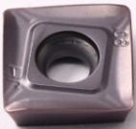 | SOMT12T308-JH | MS3015 | Carbide | PVD | Steel, S.S
2 | 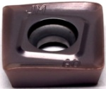 | SOMT12T308-JM | MS3015 | Carbide | PVD | Steel, S.S
3 | 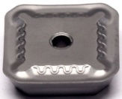 | SEMR1203AF | MS3015 | Carbide | PVD | Steel, S.S
4 | 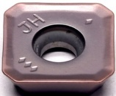 | SEMT13T3-JH | MS3015 | Carbide | PVD | Steel, S.S
5 | 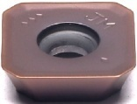 | SEMT13T3-JM | MS3015 | Carbide | PVD | Steel, S.S
6 | 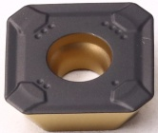 | R245-12T3M-PM | TBC2015 | Carbide | CVD | Steel
7 | 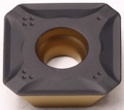 | R245-12T3M-PL | TBC2015 | Carbide | CVD | Steel
8 | 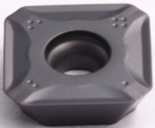 | R245-12T3M-PL | MS3030 | Carbide | PVD | Steel, stainless steel
10 | 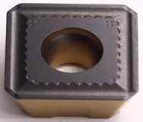 | R245-18T6M-PM | TBC2015 | Carbide | CVD | Steel
11 | 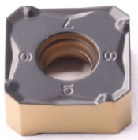 | 345R-1305M-PM | TBC2015 | Carbide | CVD | Steel
12 | 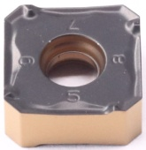 | 345R-1305M-PL | TBC2015 | Carbide | CVD | Steel
13 | 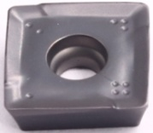 | 490R-140408M-PM | TBC2015 | Carbide | CVD | Steel

Grade: MS3015
An advanced PVD (AITIN) coating material the substrate is a high hardness material, suitable for stainless steel, high hardness material finishing.
Grade: MS3030
High Co content and fine WC grain substrate, combine with PVD AlTiN coating, which has outstanding wear resistance. Suitable for steel and stainless steel drilling.
Grade: TBC2015
The combination of high wear resistance substrate and CVD coating has strong plastic deformation resistance and edge strength. It is suitable for finishing to semi-finish machining for steel and it is easy to recognize wear.

