Carbide U Drill Inserts
Standing standard stock
Carbide Drilling Inserts
No. | Reference Photo | Type | Grade | Material | Coating | Work-piece  Materials
1 | 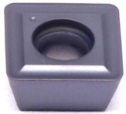 | SPMG040202-DG | MS3030 | Carbide | PVD | Steel, S.S
2 |  | SPMG050204-DG | MS3030 | Carbide | PVD | Steel, S.S
3 |  | SPMG060204-DG | MS3030 | Carbide | PVD | Steel, S.S
4 |  | SPMG07T308-DG | MS3030 | Carbide | PVD | Steel, S.S
5 |  | SDMT090408-GD | MS3030 | Carbide | PVD | Steel, S.S
6 |  | SDMT110408-GD | MS3030 | Carbide | PVD | Steel, S.S
7 |  | SDMT140408-GD | MS3030 | Carbide | PVD | Steel, S.S
8 | 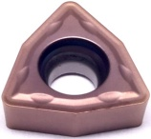 | WCMX030208-ZY | MS3060 | Carbide | PVD | Steel, S.S
9 |  | WCMX040208-ZY | MS3060 | Carbide | PVD | Steel, S.S
10 |  | WCMX050308-ZY | MS3060 | Carbide | PVD | Steel, S.S
11 |  | WCMX06T308-ZY | MS3060 | Carbide | PVD | Steel, S.S
12 |  | WCMX080412-ZY | MS3060 | Carbide | PVD | Steel, S.S

Grade: MS3030
High Co content and fine WC grain substrate, combine with PVD AlTiN coating, which has outstanding wear resistance. Suitable for steel and stainless steel drilling.

