Carbide Inserts for Small Parts
Standing standard stock
Carbide Inserts for Miniature
No. | Reference Photo | Type | Grade | Material | Coating | Work-piece Materials
1 | 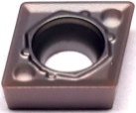 | CCMT060202-Q1 | MS3050 | Carbide | PVD | Steel, S.S
2 |  | CCMT060204-Q1 | MS3050 | Carbide | PVD | Steel, S.S
3 | 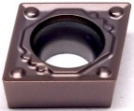 | CCMT09T302-Q1 | MS3050 | Carbide | PVD | Steel, S.S
4 |  | CCMT09T304-Q1 | MS3050 | Carbide | PVD | Steel, S.S
5 |  | CCMT09T308-Q1 | MS3050 | Carbide | PVD | Steel, S.S
6 | 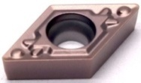 | DCMT070202-Q1 | MS3050 | Carbide | PVD | Steel, S.S
7 |  | DCMT070204-Q1 | MS3050 | Carbide | PVD | Steel, S.S
8 |  | DCMT070208-Q1 | MS3050 | Carbide | PVD | Steel, S.S
9 | 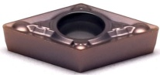 | DCMT070204-MV | MS3050 | Carbide | PVD | Steel, S.S
10 | 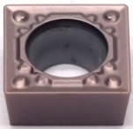 | SCMT09T304-Q1 | MS3050 | Carbide | PVD | Steel, S.S
11 |  | SCMT09T308-Q1 | MS3050 | Carbide | PVD | Steel, S.S
12 | 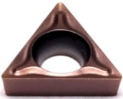 | TBMT060102-DP | MS3050 | Carbide | PVD | Steel, S.S
13 |  | TBMT060104-DP | MS3050 | Carbide | PVD | Steel, S.S
14 | 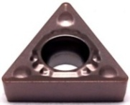 | TCMT090204-Q1 | MS3050 | Carbide | PVD | Steel, S.S
15 |  | TCMT090208-Q1 | MS3050 | Carbide | PVD | Steel, S.S
16 | 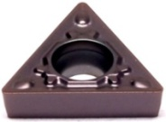 | TCMT110202-Q1 | MS3050 | Carbide | PVD | Steel, S.S
17 |  | TCMT110204-Q1 | MS3050 | Carbide | PVD | Steel, S.S
18 |  | TCMT110208-Q1 | MS3050 | Carbide | PVD | Steel, S.S
19 | 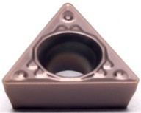 | TPMT110304-Q1 | MS3050 | Carbide | PVD | Steel, S.S
20 |  | TPMT110308-Q1 | MS3050 | Carbide | PVD | Steel, S.S
21 | 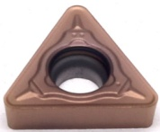 | TCMT110202-69 | MS3050 | Carbide | PVD | Steel, S.S
22 |  | TCMT110204-69 | MS3050 | Carbide | PVD | Steel, S.S
23 |  | TCMT110208-69 | MS3050 | Carbide | PVD | Steel, S.S
24 | 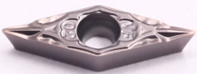 | VCMT080202-VF | MS3050 | Carbide | PVD | Steel, S.S
25 |  | VCMT080204-VF | MS3050 | Carbide | PVD | Steel, S.S
26 |  | VBMT110302-VF | MS3050 | Carbide | PVD | Steel, S.S
27 |  | VBMT110304-VF | MS3050 | Carbide | PVD | Steel, S.S
28 | 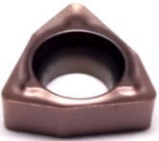 | WBMT060102L-DP | MS3050 | Carbide | PVD | Steel, S.S
29 |  | WBMT060104L-DP | MS3050 | Carbide | PVD | Steel, S.S
Grade: MS3050
High Co content and fine WC grain substrate, combine with good thermal stability silicon coating, it has low friction coefficient and good hardness，very suitable for miniatures of steel and stainless steel that has high requirement for surface finish.

Carbide Inserts for Automatic Lathe Machine
No. | Reference  Photo | Type | Grade | Material | Coating | Work-piece  Materials
1 | 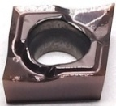 | CCGT060201-YL | MS3015 | Carbide | PVD | Steel, S.S
2 |  | CCGT060202-YL | MS3015 | Carbide | PVD | Steel, S.S
3 |  | CCGT060204-YL | MS3015 | Carbide | PVD | Steel, S.S
4 | 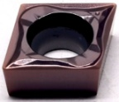 | CCGT09T301-YL | MS3015 | Carbide | PVD | Steel, S.S
5 |  | CCGT09T302-YL | MS3015 | Carbide | PVD | Steel, S.S
6 |  | CCGT09T304-YL | MS3015 | Carbide | PVD | Steel, S.S
7 | 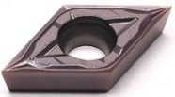 | DCGT070201-YL | MS3015 | Carbide | PVD | Steel, S.S
8 |  | DCGT070202-YL | MS3015 | Carbide | PVD | Steel, S.S
9 |  | DCGT070204-YL | MS3015 | Carbide | PVD | Steel, S.S
10 |  | DCGT11T301-YL | MS3015 | Carbide | PVD | Steel, S.S
11 |  | DCGT11T302-YL | MS3015 | Carbide | PVD | Steel, S.S
12 |  | DCGT11T304-YL | MS3015 | Carbide | PVD | Steel, S.S
13 | 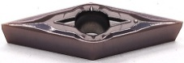 | VBGT110301-YL | MS3015 | Carbide | PVD | Steel, S.S
14 |  | VBGT110302-YL | MS3015 | Carbide | PVD | Steel, S.S
15 |  | VBGT110304-YL | MS3015 | Carbide | PVD | Steel, S.S
16 |  | VCGT110301-YL | MS3015 | Carbide | PVD | Steel, S.S
17 |  | VCGT110302-YL | MS3015 | Carbide | PVD | Steel, S.S
18 |  | VCGT110304-YL | MS3015 | Carbide | PVD | Steel, S.S
19 |  | VBGT160402-YL | MS3015 | Carbide | PVD | Steel, S.S
20 |  | VBGT160404-YL | MS3015 | Carbide | PVD | Steel, S.S
21 |  | VCGT160402-YL | MS3015 | Carbide | PVD | Steel, S.S
22 |  | VCGT160404-YL | MS3015 | Carbide | PVD | Steel, S.S
23 | 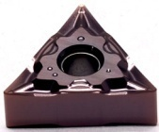 | TNGG160401-UL | MS3015 | Carbide | PVD | Steel, S.S
24 |  | TNGG160402-UL | MS3015 | Carbide | PVD | Steel, S.S
25 |  | TNGG160404-UL | MS3015 | Carbide | PVD | Steel, S.S
Our company mainly promotes -YL groove type and -UL groove type for steel and stainless steel processing.
Grade: MS3015
PVD (TiN+TiCN) is suitable for high-precision processing of stainless steel and low carbon steel, with excellent sharpness and solubility.

Chip-breaker YL & UL
Recommended Cutting Parameters
Chip-breaker | Ap | F | Vc
YL | 0.3-2.5 | 0.07-0.25 | 70-150
UL | 0.25-2.5 | 0.05-0.15 | 70-15

