Carbide Turning Inserts for High Hard Materials
Standing standard stock
Carbide Inserts for High Hardness Material
No. | Reference Photo | Insert Type | Grade | Material | Coating | Work-piece Materials
1 | 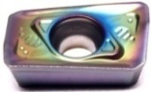 | APMT1135-69 | MS1010 | Carbide | PVD | High hardness material, S.S316
2 | 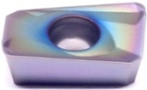 | APMT1135-H2 | MS1010 | Carbide | PVD | High hardness material, S.S316
3 | 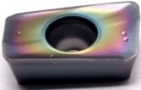 | APMT1135-TT | MS1010 | Carbide | PVD | High hardness material, S.S316
4 | 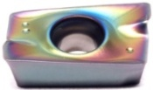 | APMT1604-TT | MS1010 | Carbide | PVD | High hardness material, S.S316
5 | 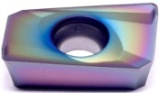 | APMT1604-H2 | MS1010 | Carbide | PVD | High hardness material, S.S316
6 | 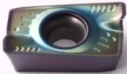 | APMT1604-69 | MS1010 | Carbide | PVD | High hardness material, S.S316
7 | 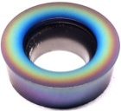 | R5-TT | MS1010 | Carbide | PVD | High hardness material, S.S316
8 | 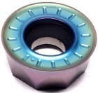 | R6-TT | MS1010 | Carbide | PVD | High hardness material, S.S316
9 | 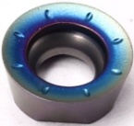 | RPMT10T3MO-TT | MS1010 | Carbide | PVD | High hardness material, S.S316
10 | 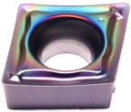 | CCMT060204-63 | MS1010 | Carbide | PVD | High hardness material, S.S316
11 |  | CCMT09T304-63 | MS1010 | Carbide | PVD | High hardness material, S.S316
12 | 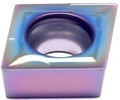 | CCMT060204-TF | MS1010 | Carbide | PVD | High hardness material, S.S316
13 |  | CCMT060208-TF | MS1010 | Carbide | PVD | High hardness material, S.S316
14 |  | CCMT09T302-TF | MS1010 | Carbide | PVD | High hardness material, S.S316
15 |  | CCMT09T308-TF | MS1010 | Carbide | PVD | High hardness material, S.S316
16 |  | CCMT09T304-TF | MS1010 | Carbide | PVD | High hardness material, S.S316
17 |  | CCMT120404-TF | MS1010 | Carbide | PVD | High hardness material, S.S316
18 |  | CCMT120408-TF | MS1010 | Carbide | PVD | High hardness material, S.S316
19 | 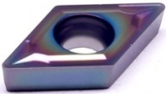 | DCMT070204-TF | MS1010 | Carbide | PVD | High hardness material, S.S316
20 |  | DCMT070208-TF | MS1010 | Carbide | PVD | High hardness material, S.S316
21 |  | DCMT11T304-TF | MS1010 | Carbide | PVD | High hardness material, S.S316
22 |  | DCMT11T308-TF | MS1010 | Carbide | PVD | High hardness material, S.S316
23 | 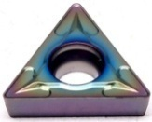 | TCMT110202-TF | MS1010 | Carbide | PVD | High hardness material, S.S316
24 |  | TCMT110204-TF | MS1010 | Carbide | PVD | High hardness material, S.S316
25 |  | TCMT110208-TF | MS1010 | Carbide | PVD | High hardness material, S.S316
26 |  | TCMT16T304-TF | MS1010 | Carbide | PVD | High hardness material, S.S316
27 |  | TCMT16T308-TF | MS1010 | Carbide | PVD | High hardness material, S.S316
28 | 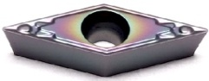 | VCMT080202-HQ | MS1010 | Carbide | PVD | High hardness material, S.S316
29 |  | VCMT080204-HQ | MS1010 | Carbide | PVD | High hardness material, S.S316
30 |  | VBMT110304-HQ | MS1010 | Carbide | PVD | High hardness material, S.S316
31 |  | VBMT110308-HQ | MS1010 | Carbide | PVD | High hardness material, S.S316
32 | 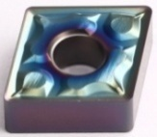 | CNMG120404-63 | MS1010 | Carbide | PVD | High hardness material, S.S316
33 |  | CNMG120408-63 | MS1010 | Carbide | PVD | High hardness material, S.S316
34 | 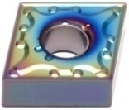 | CNMG120404-SL | MS1010 | Carbide | PVD | High hardness material, S.S316
35 |  | CNMG120408-SL | MS1010 | Carbide | PVD | High hardness material, S.S316
36 | 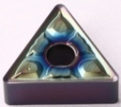 | TNMG160404-63 | MS1010 | Carbide | PVD | High hardness material, S.S316
37 |  | TNMG160408-63 | MS1010 | Carbide | PVD | High hardness material, S.S316
38 | 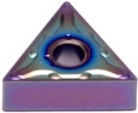 | TNMG160404-SL | MS1010 | Carbide | PVD | High hardness material, S.S316
39 |  | TNMG160408-SL | MS1010 | Carbide | PVD | High hardness material, S.S316
40 | 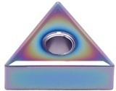 | TNMG160404-MS | MS1010 | Carbide | PVD | High hardness material, S.S316
41 | 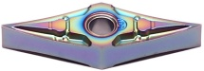 | VNMG160402-69 | MS1010 | Carbide | PVD | High hardness material, S.S316
42 | 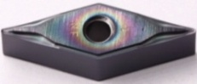 | VNMG160404-NF | MS1010 | Carbide | PVD | High hardness material, S.S316
43 | 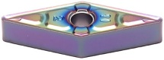 | VNMG160408-63 | MS1010 | Carbide | PVD | High hardness material, S.S316
44 | 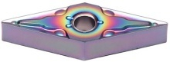 | VNMG160404-SL | MS1010 | Carbide | PVD | High hardness material, S.S316
45 |  | VNMG160408-SL | MS1010 | Carbide | PVD | High hardness material, S.S316
46 | 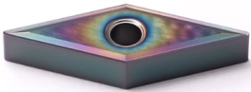 | VNMG160404-MS | MS1010 | Carbide | PVD | High hardness material, S.S316
47 | 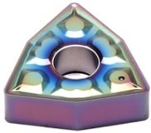 | WNMG080404-63 | MS1010 | Carbide | PVD | High hardness material, S.S316
48 |  | WNMG080408-63 | MS1010 | Carbide | PVD | High hardness material, S.S316
49 | 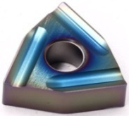 | WNMG080404L-S | MS1010 | Carbide | PVD | High hardness material, S.S316
50 |  | WNMG080404R-S | MS1010 | Carbide | PVD | High hardness material, S.S316
51 |  | WNMG080408L-S | MS1010 | Carbide | PVD | High hardness material, S.S316
52 |  | WNMG080408R-S | MS1010 | Carbide | PVD | High hardness material, S.S316
53 | 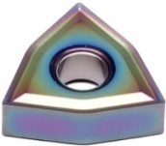 | WNMG080404-MS | MS1010 | Carbide | PVD | High hardness material, S.S316
54 |  | WNMG080408-MS | MS1010 | Carbide | PVD | High hardness material, S.S316
55 | 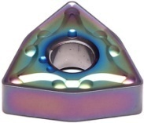 | WNMG080404-SL | MS1010 | Carbide | PVD | High hardness material, S.S316
56 |  | WNMG080408-SL | MS1010 | Carbide | PVD | High hardness material, S.S316
Grade: MS1010
Ultra-fine-grain WC substrate combined with AlTiN coating, suitable for turning and milling of stainless steel and high hard materials.

Chip-breaker：63
Recommended Cutting Parameters
Chip-breaker | Ap | NAP | Vc
63(negative) | 1.0-4.0 | 0.12-0.35 | 20-80
63(positive) | 0.3-2.5 | 0.05-0.25 | 20-70

Chip-breaker：TF, Q1 & 69
Recommended Cutting Parameters
Chip-breaker | Ap | NAP | Vc
TF | 0.35-1.8 | 0.05-0.25 | 20-70
Q1 | 0.3-2.3 | 0.05-0.22 | 20-70
69 | 0.3-1.0 | 0.1-0.4 | 60-100

Chip-breaker：MS, SL & R-S, L-S
Recommended Cutting Parameters
Chip-breaker | Ap | NAP | Vc
MS | 0.4-2.5 | 0.1-0.3 | 60-100
SL | 0.25-3.5 | 0.15-0.35 | 60-100
R-S | 0.8-3.5 | 0.18-0.35 | 70-100
L-S | 0.8-3.5 | 0.18-0.35 | 70-100

